SAP BTP - PBC - Workshop

Subaccount Setup

Contents

Cloud Foundry Runtime 2

SAP AI Core 6

SAP AI Launchpad 10

SAP HANA Cloud 13

SAP Business Application Studio 18

SAP Build Work Zone, standard edition 23

Configure SAP HANA Cloud Instance 27

Configure AI Launchpad Integration to AI Core 41

Create AI Core Destination 45

The information required to create the destination will be found in the AI Core’s Service Key instance. 46

# Cloud Foundry Runtime

**Plan Name:** MEMORY

**Manual Setup:** <https://help.sap.com/docs/cf-runtime/cloud-foundry-runtime/initial-setup?locale=en-US>

**Using Booster:** <https://YOUR_SAP_BTP_GLOBAL_ACCOUNT/booster/8499b227-1498-473a-b24a-1f0968f93459>

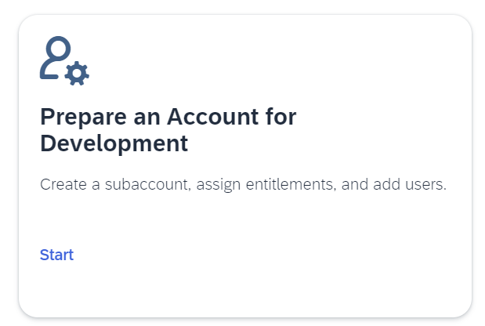

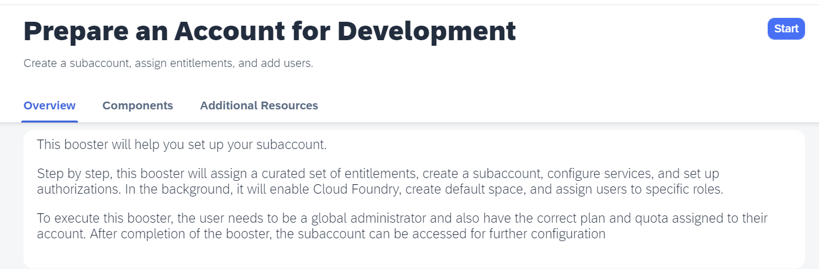

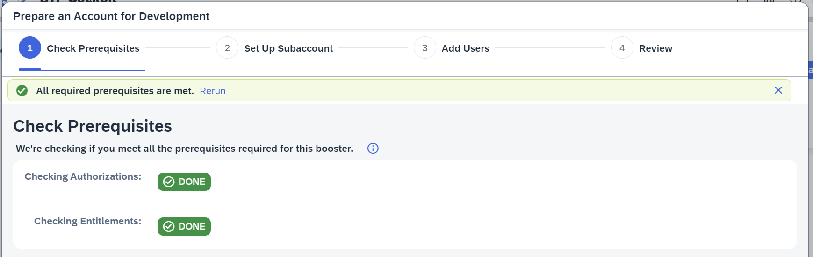

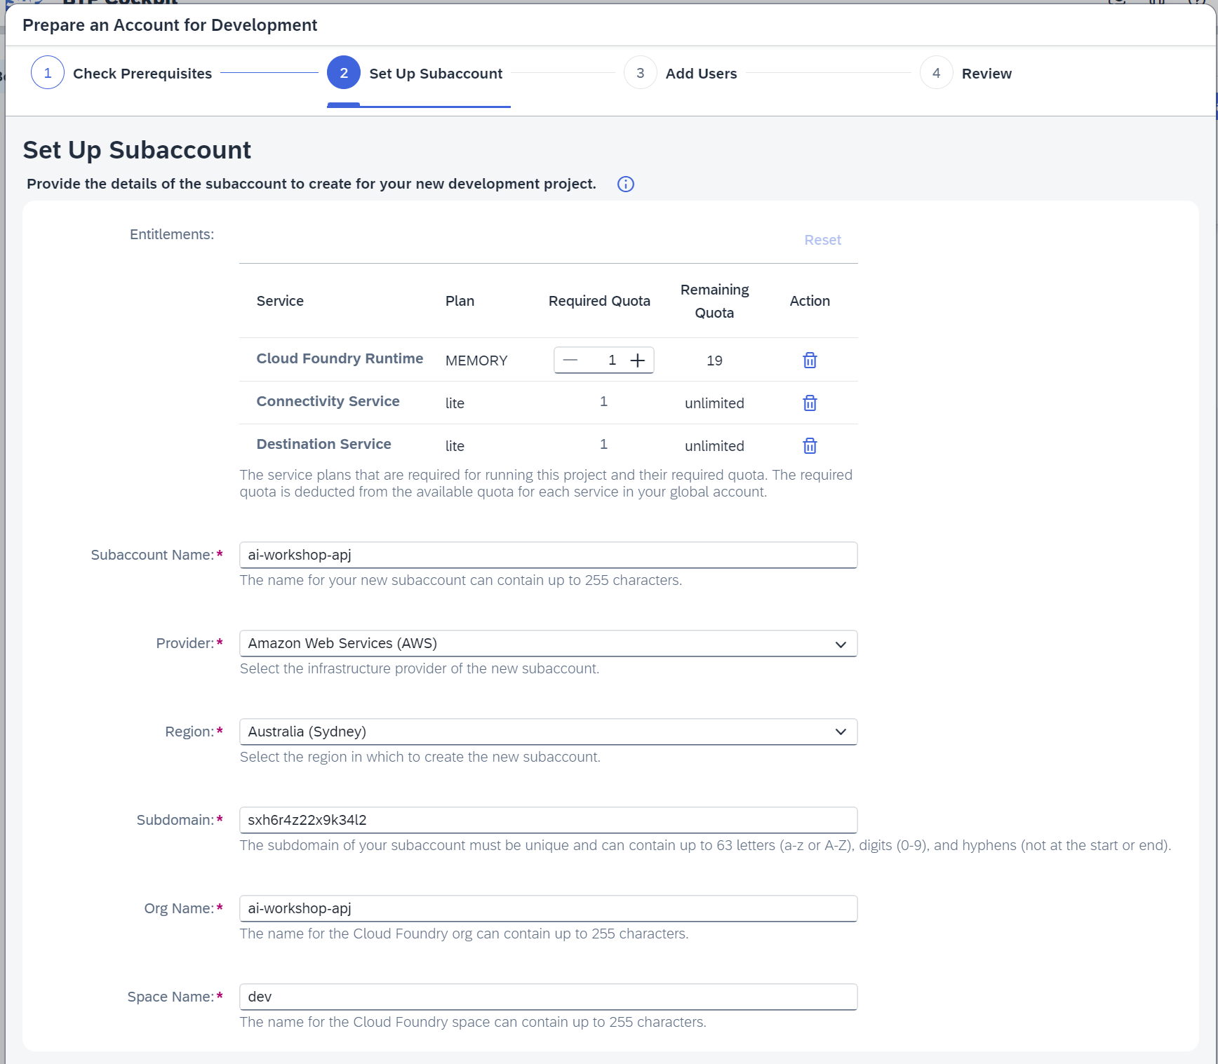

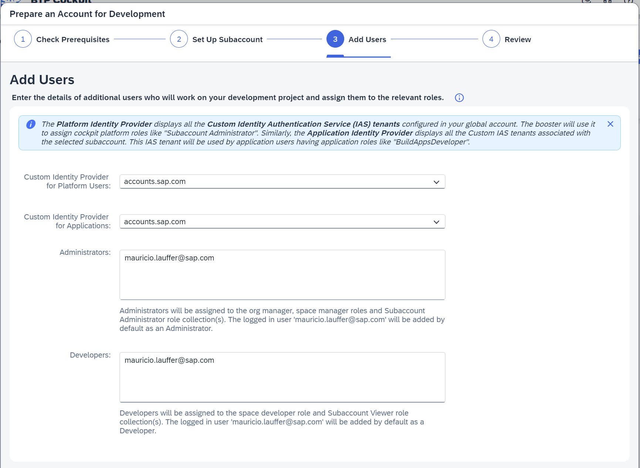

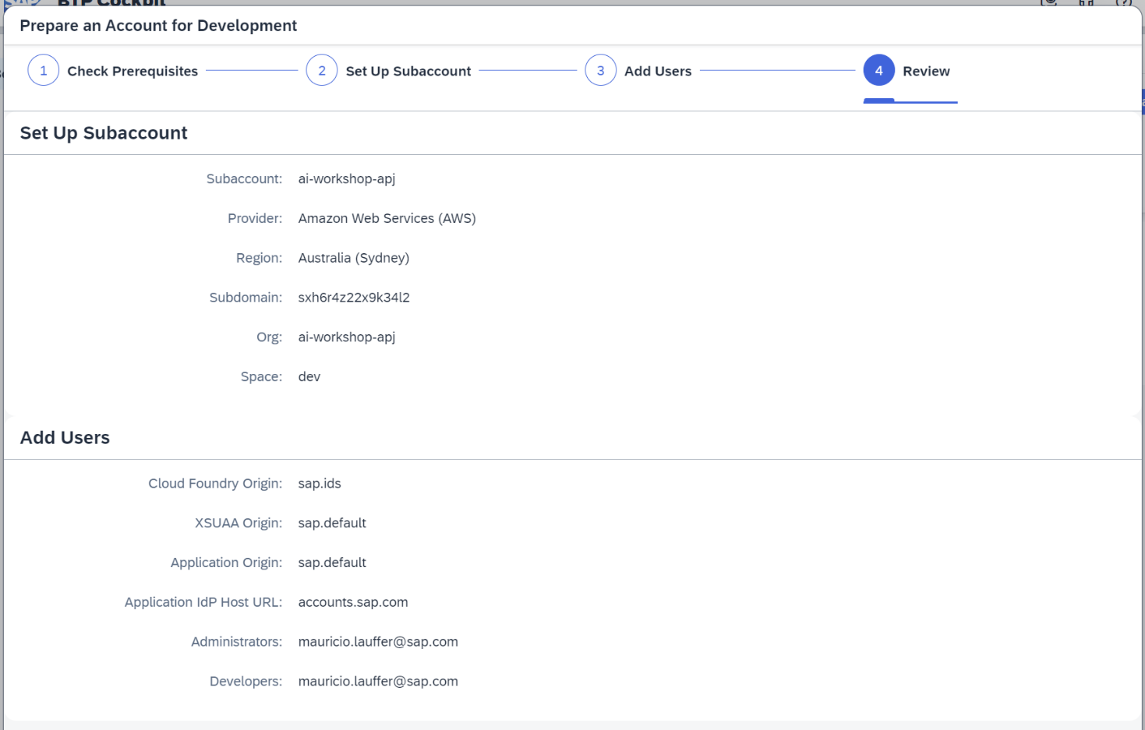

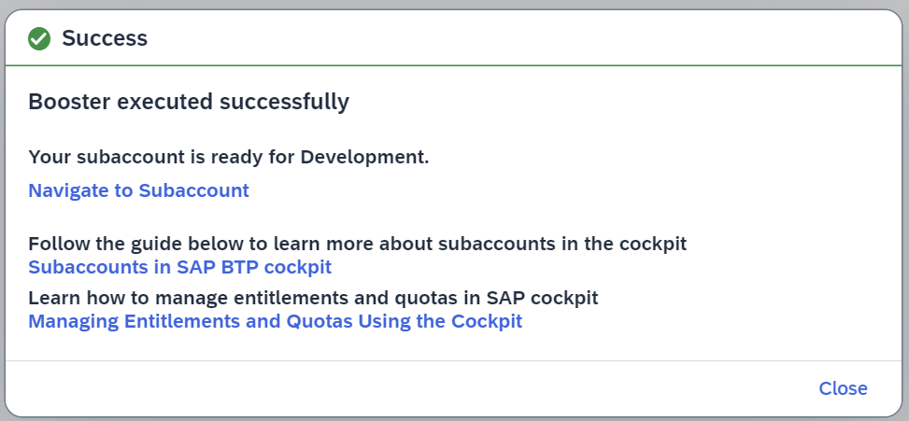

# SAP AI Core

**Plan Name:** extended

**Manual setup:** <https://help.sap.com/docs/sap-ai-core/sap-ai-core-service-guide/enabling-service-in-cloud-foundry?locale=en-US>

**Using Booster:** <https://YOUR_SAP_BTP_GLOBAL_ACCOUNT/booster/aicore>

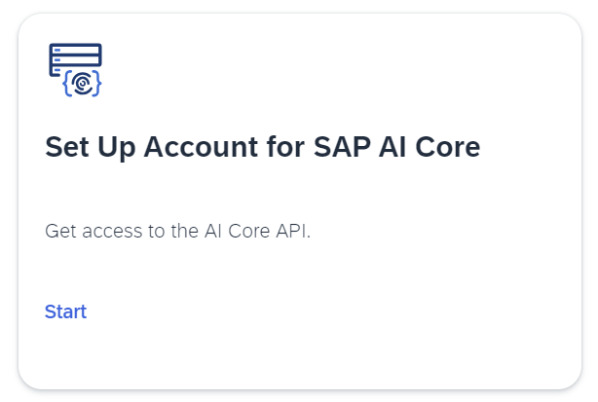

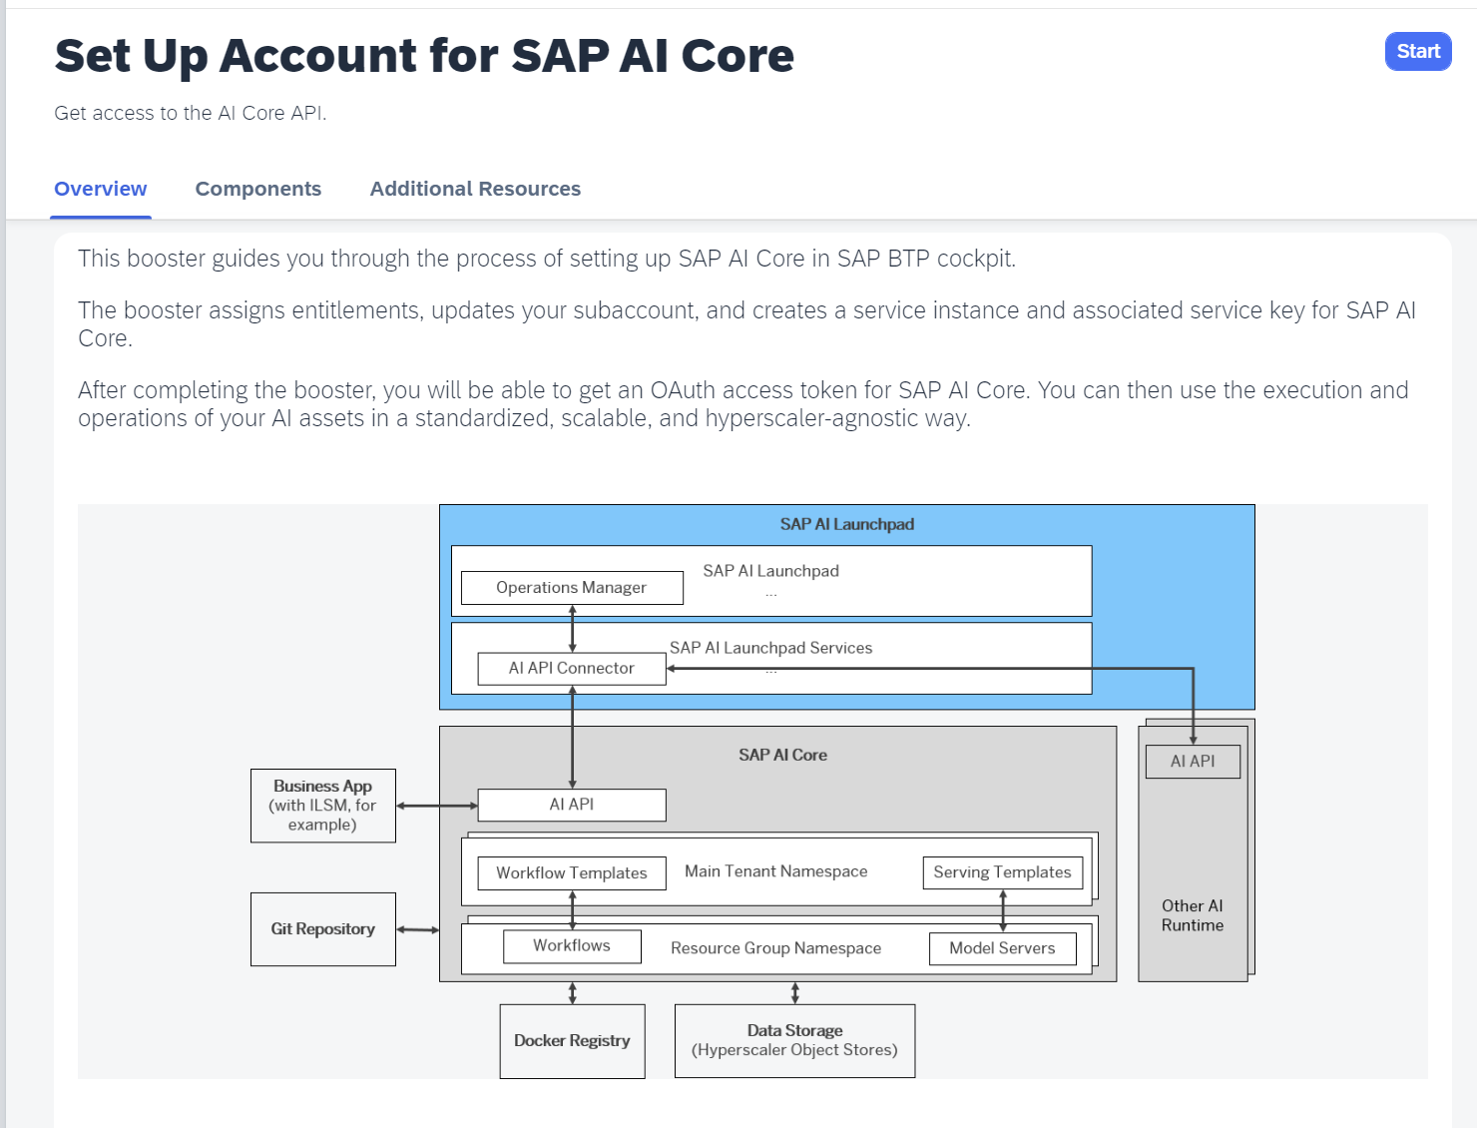

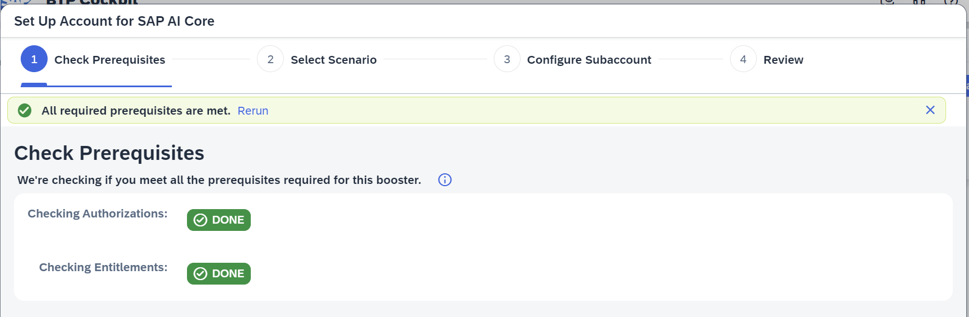

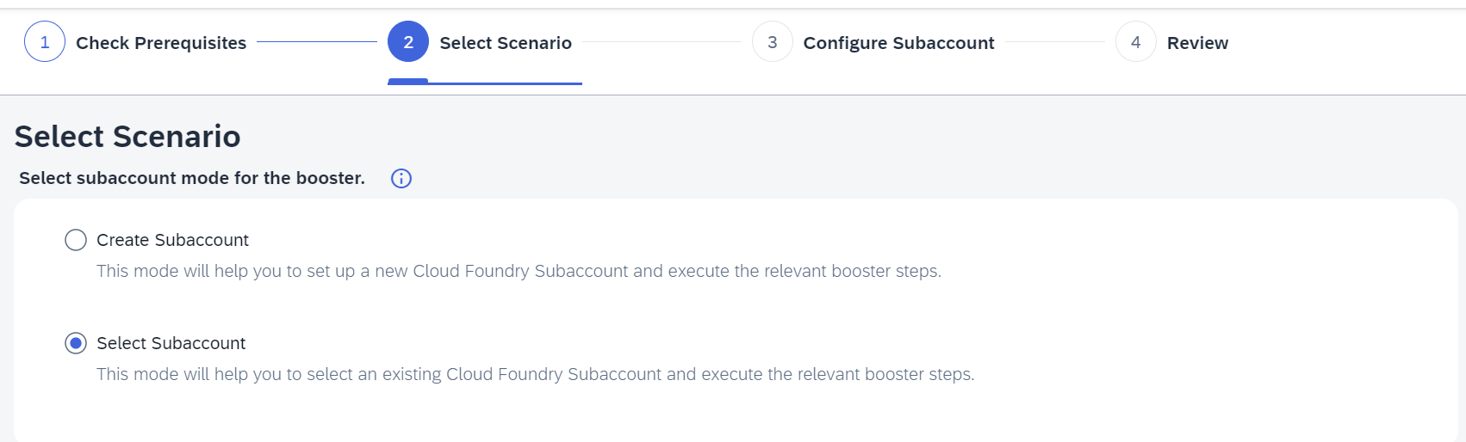

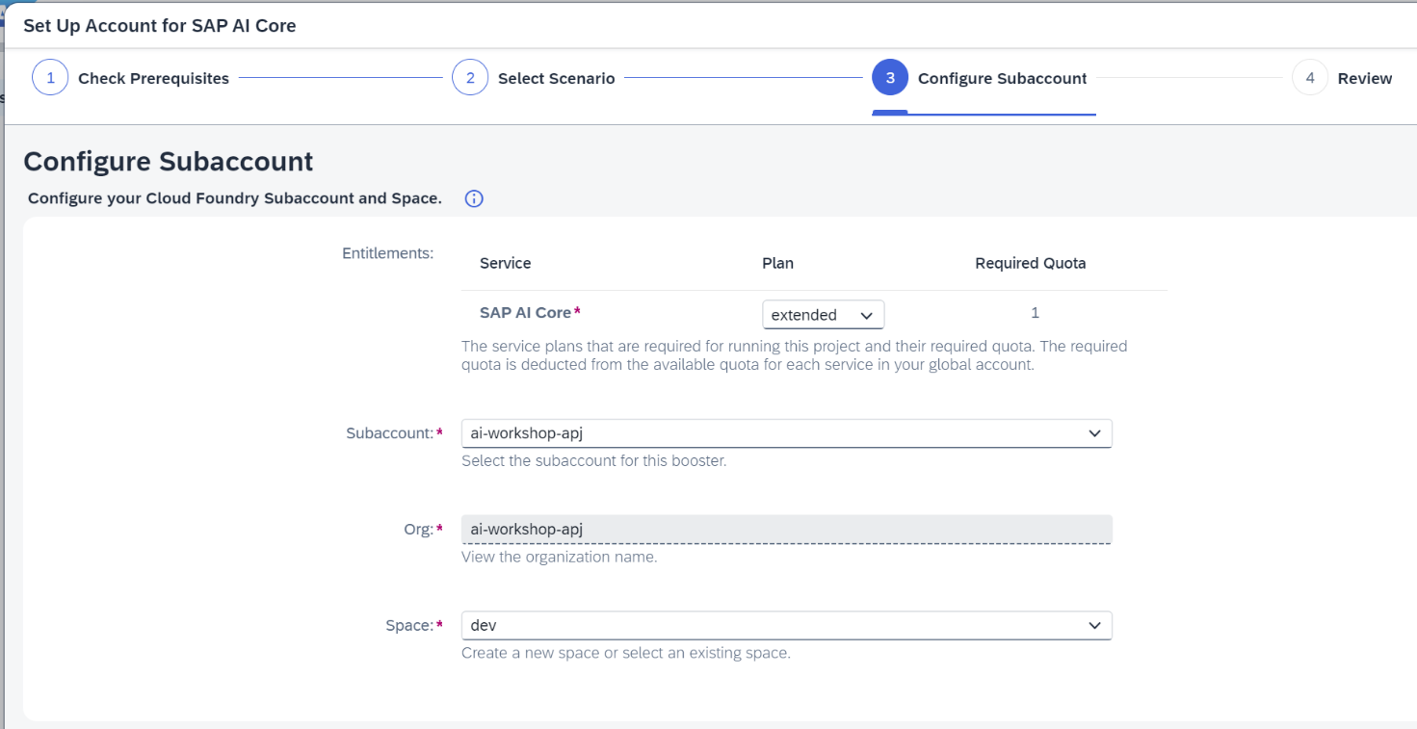

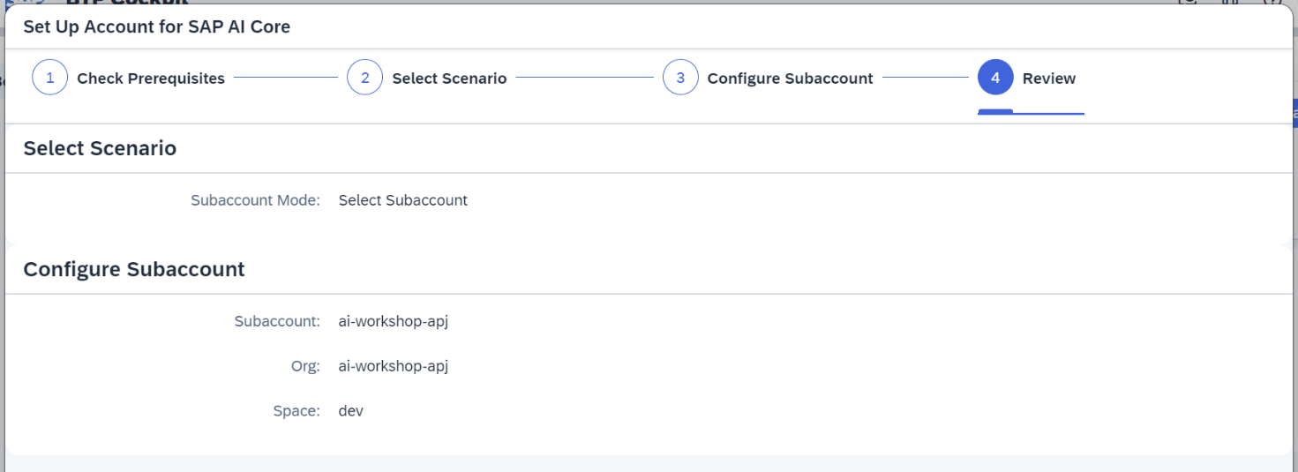

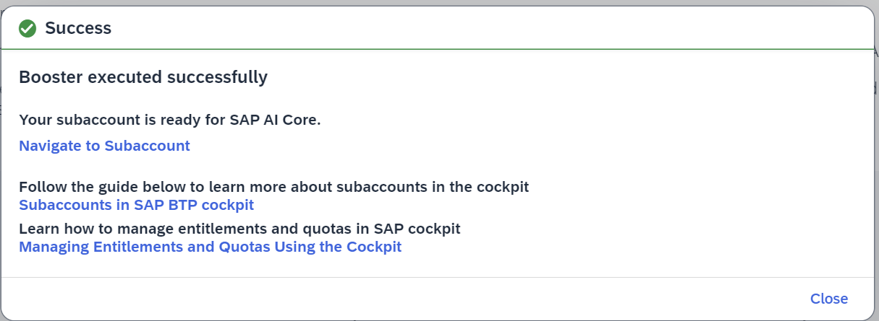

# SAP AI Launchpad

**Plan Name:** standard

**Manual setup:** <https://help.sap.com/docs/ai-launchpad/sap-ai-launchpad/initial-setup?locale=en-US>

**Using Booster:** <https://YOUR_SAP_BTP_GLOBAL_ACCOUNT/booster/ai-launchpad>

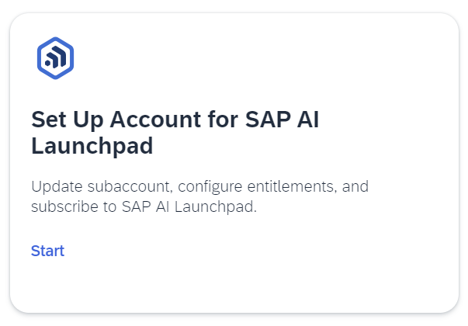

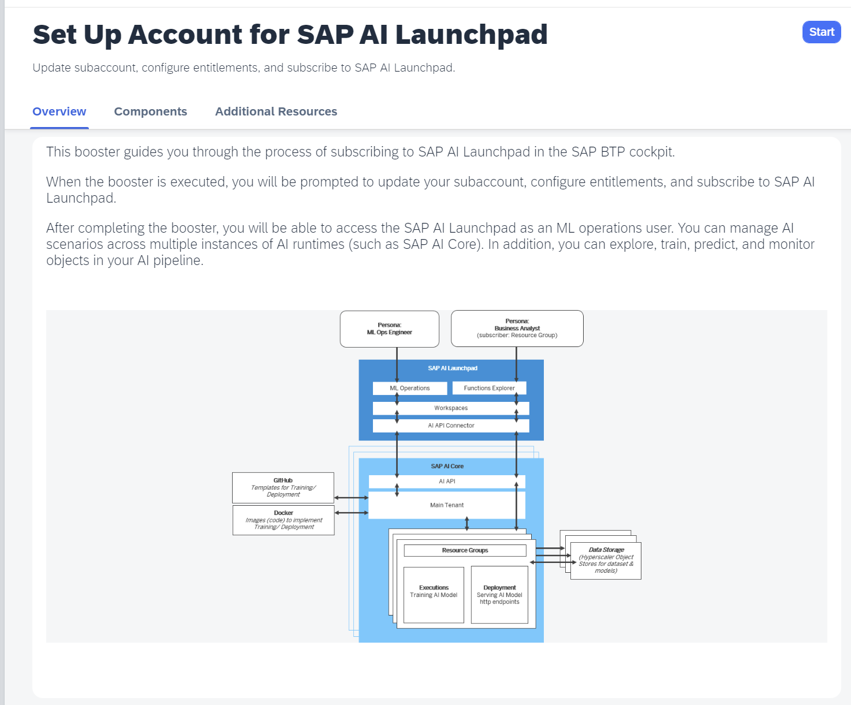

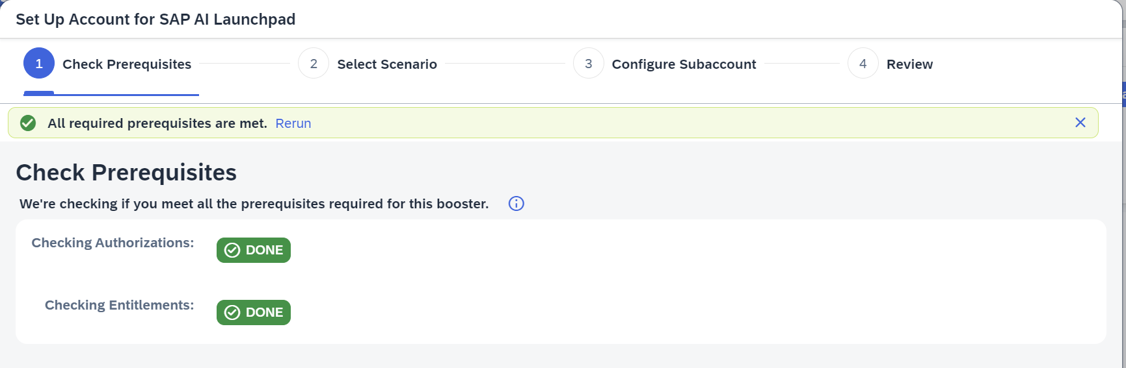



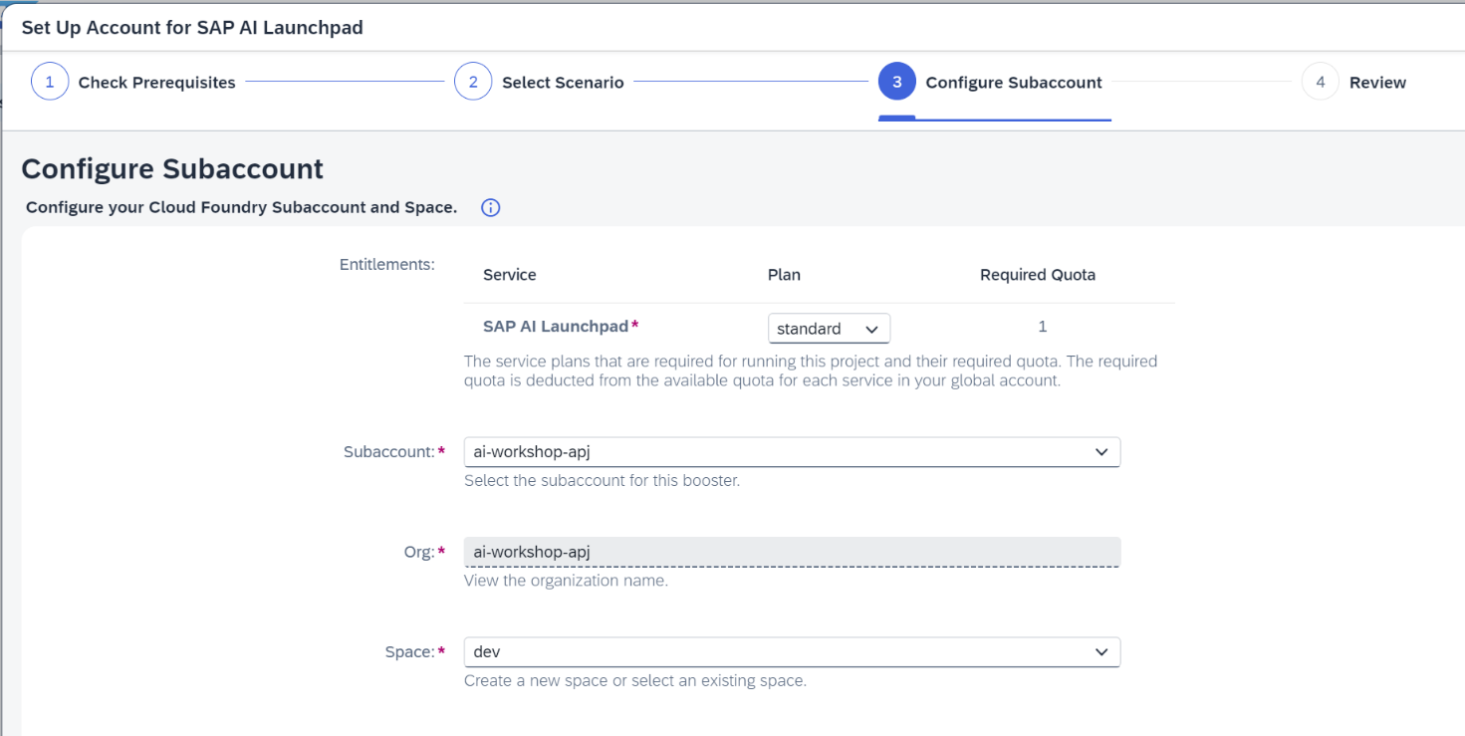

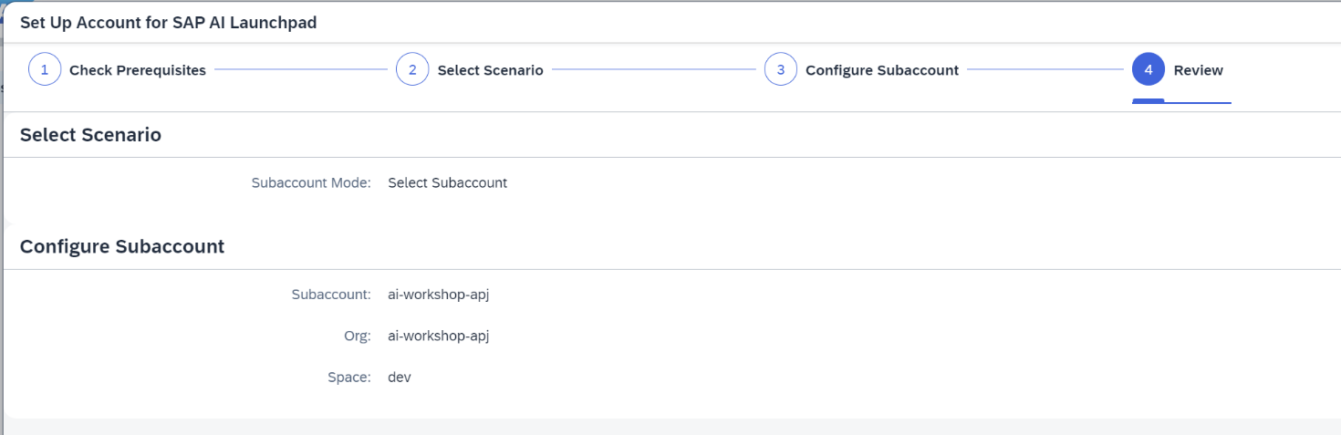

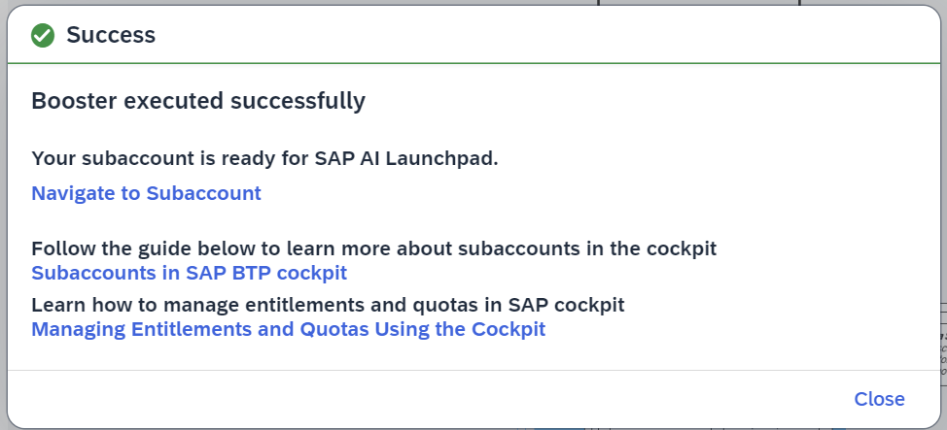

# SAP HANA Cloud

**Plan Name:** hana

**Plan Name:** tools

**Manual Setup:** <https://help.sap.com/docs/hana-cloud/sap-hana-cloud-administration-guide/create-sap-hana-database-instance-using-sap-hana-cloud-central>

**Using Booster:** <https://YOUR_SAP_BTP_GLOBAL_ACCOUNT/booster/hana-cloud-tooling>

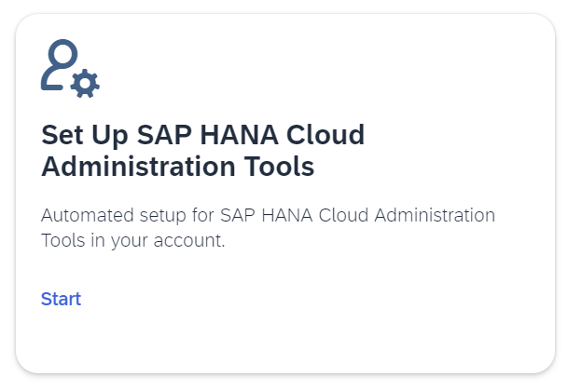

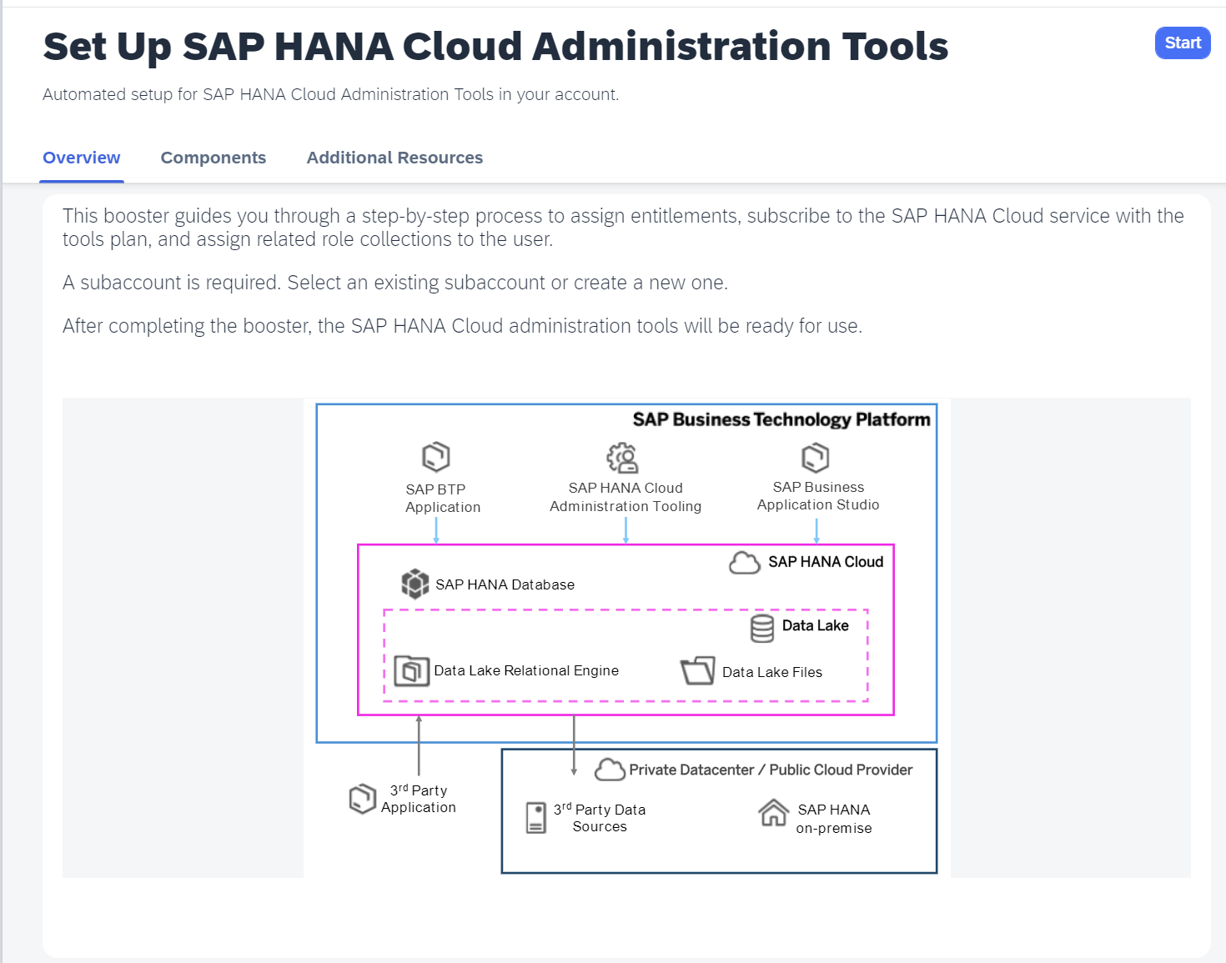

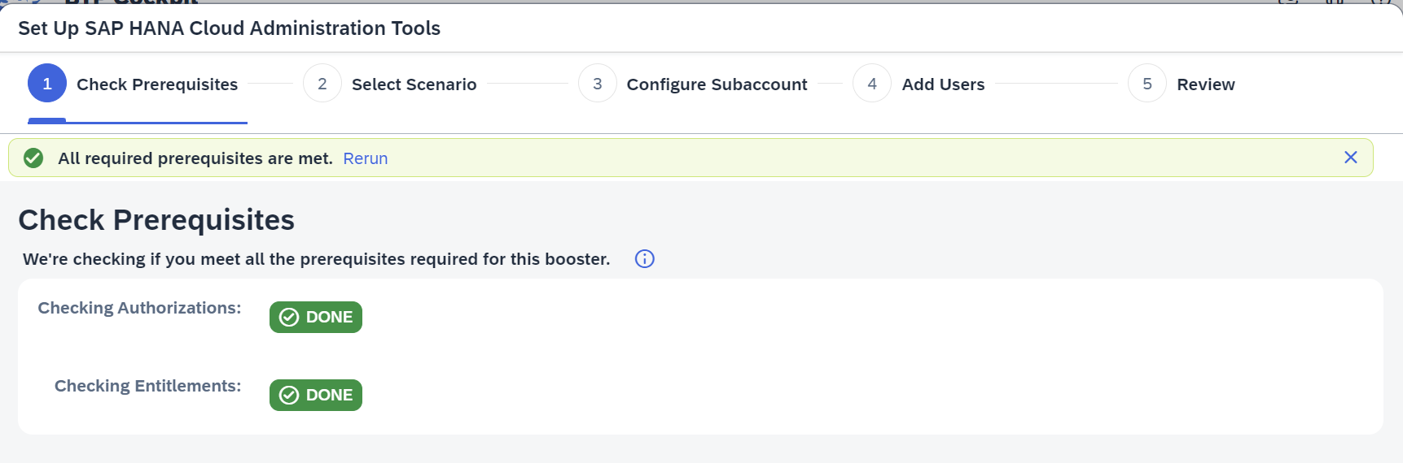

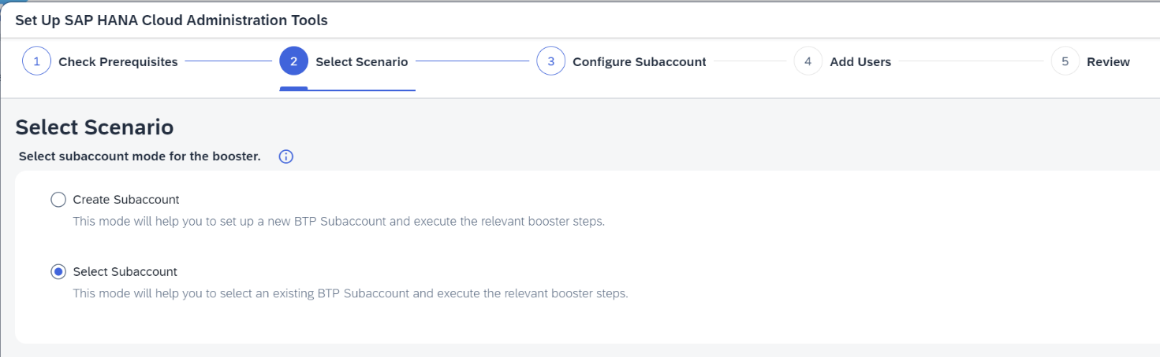

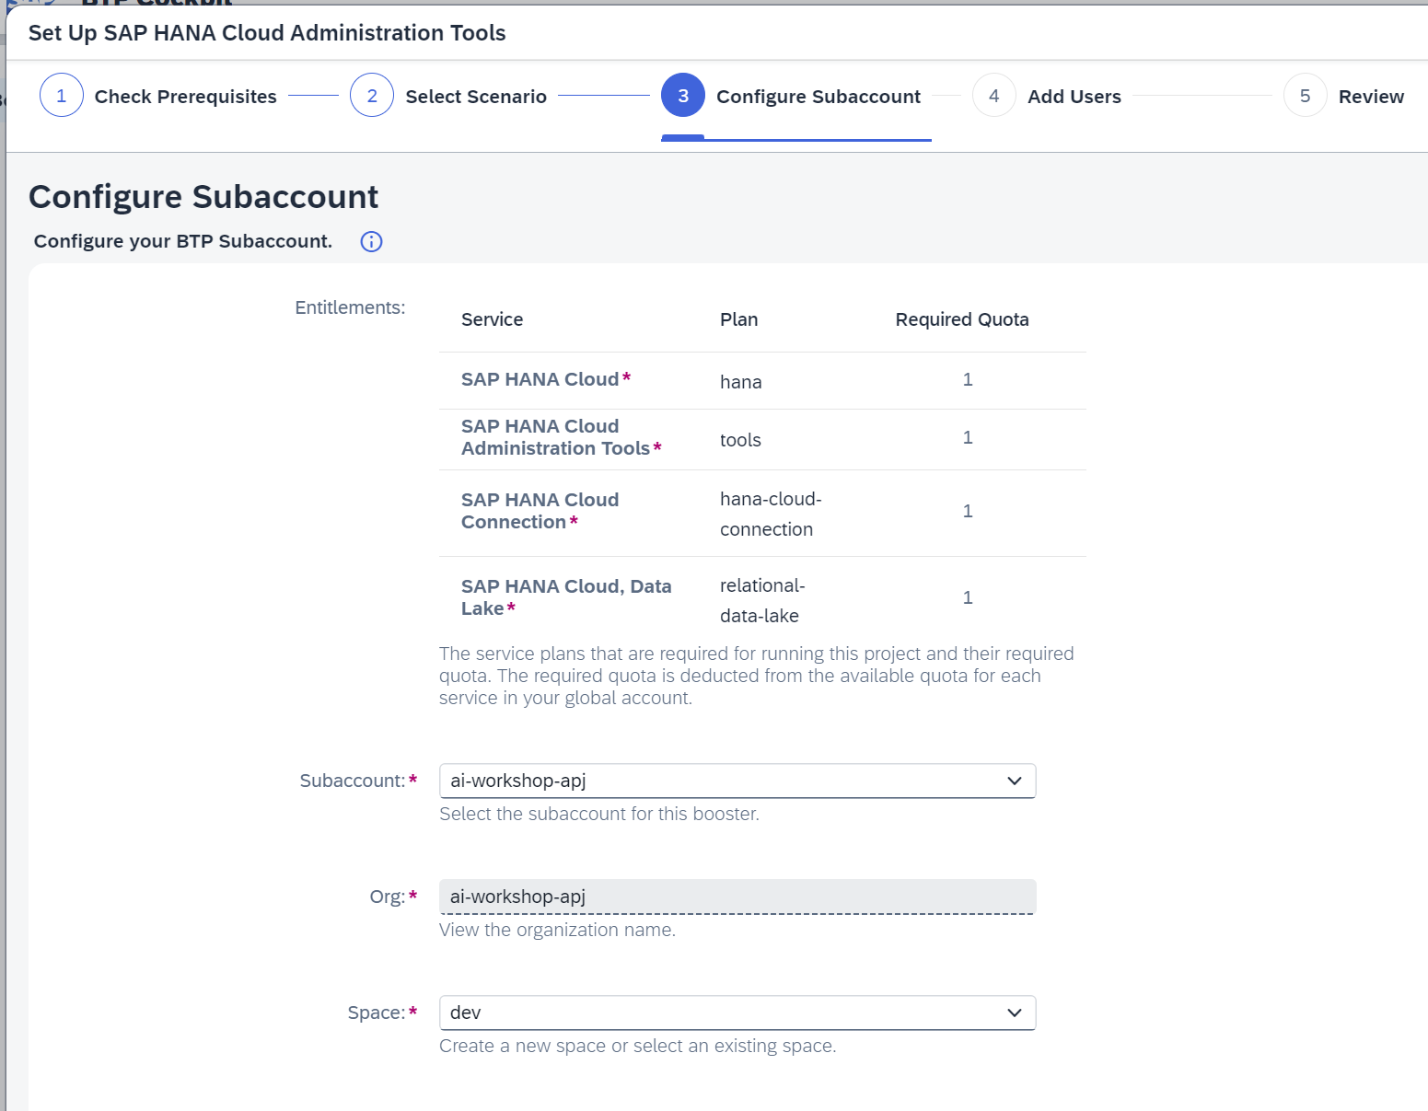

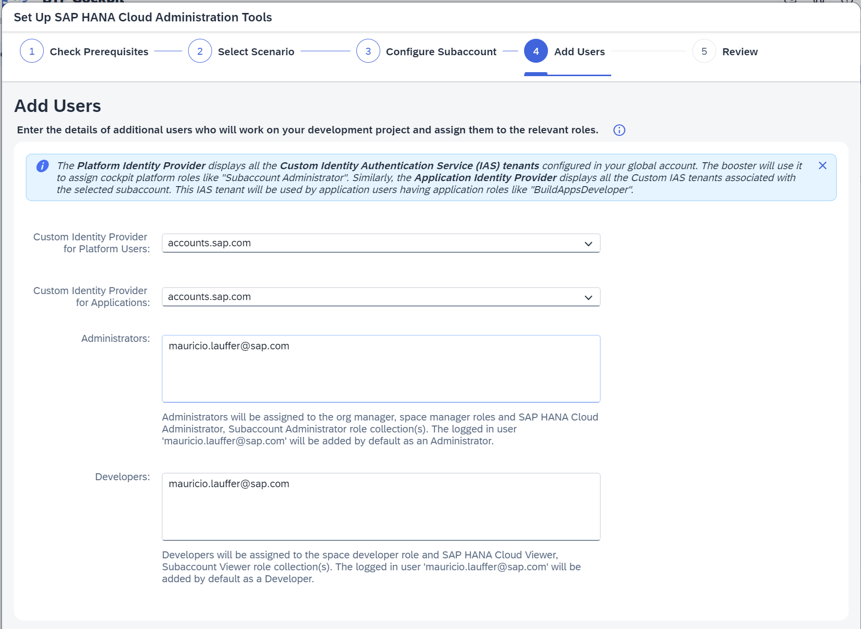

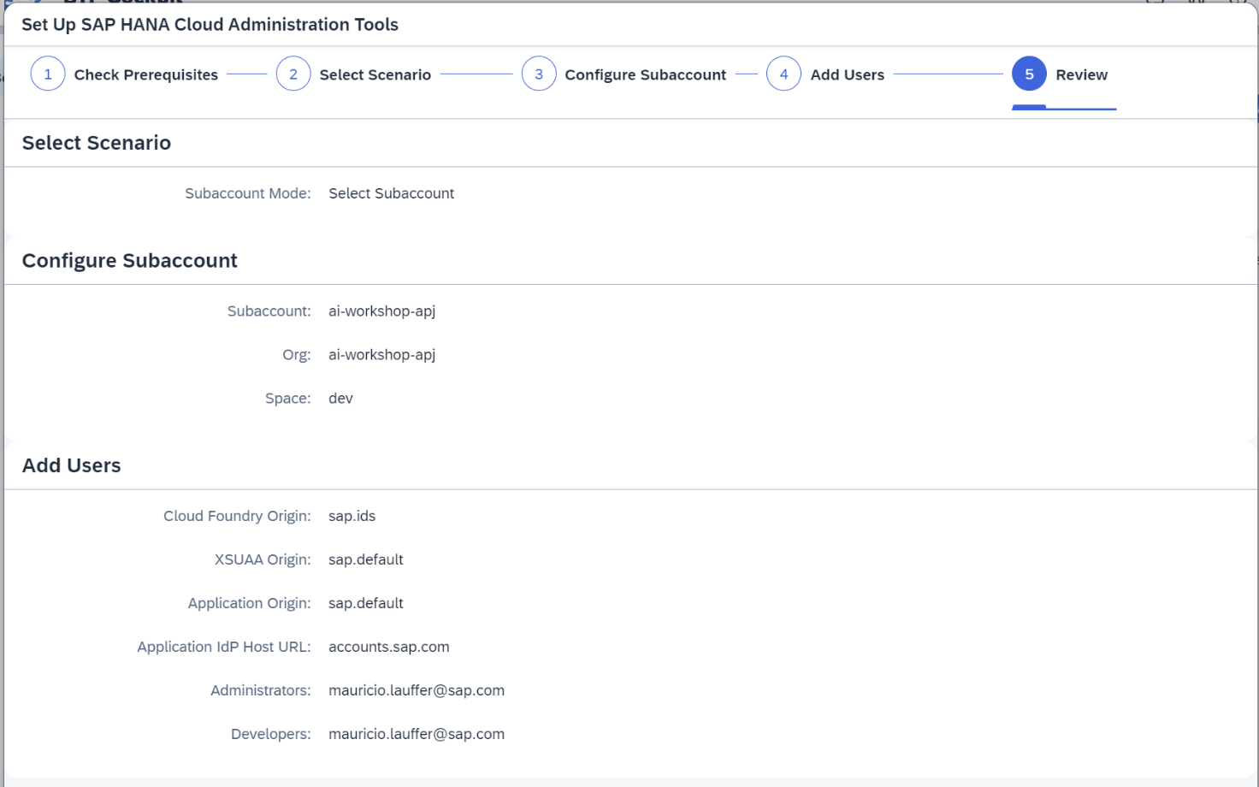

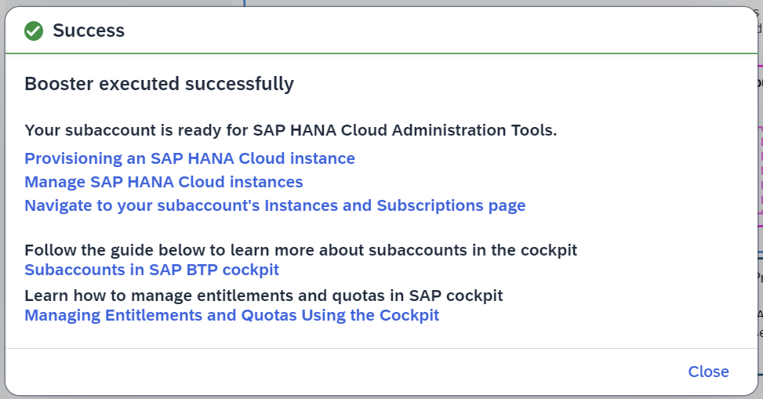

# SAP Business Application Studio

**Plan Name:** standard-edition

**Manual Setup:** <https://help.sap.com/docs/bas/sap-business-application-studio/getting-started>

**Using Booster:** <https://YOUR_SAP_BTP_GLOBAL_ACCOUNT/booster/bas-ptk>

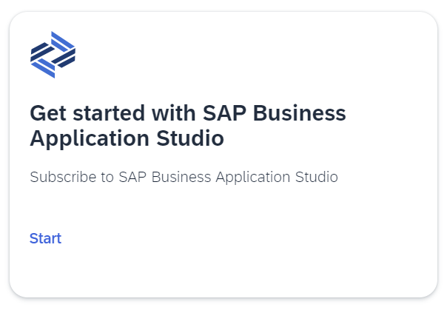

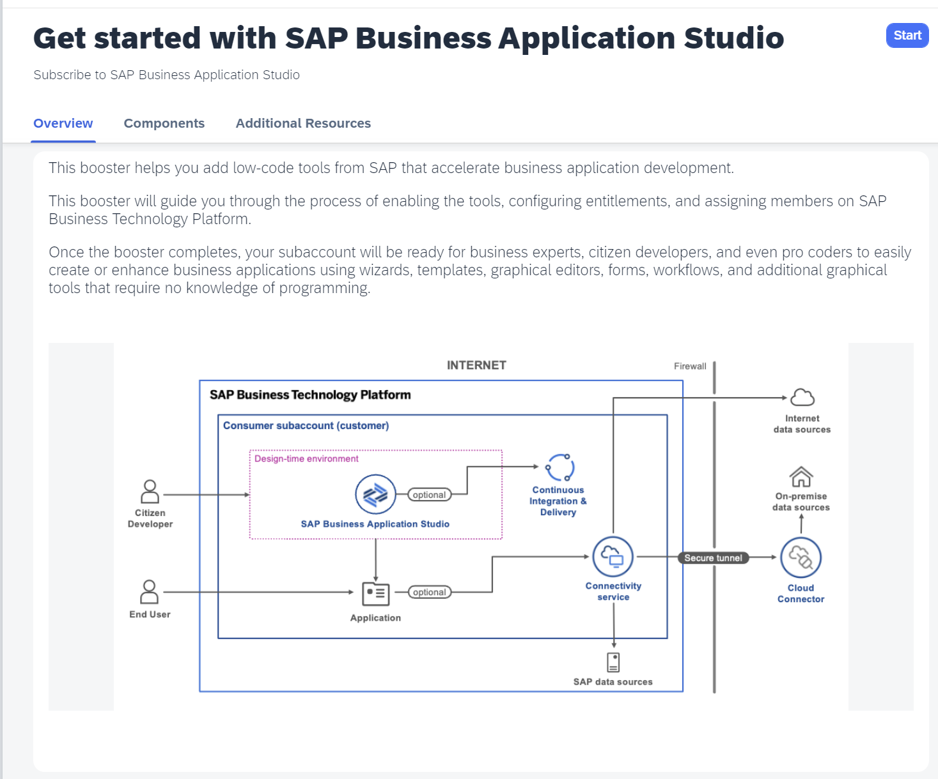

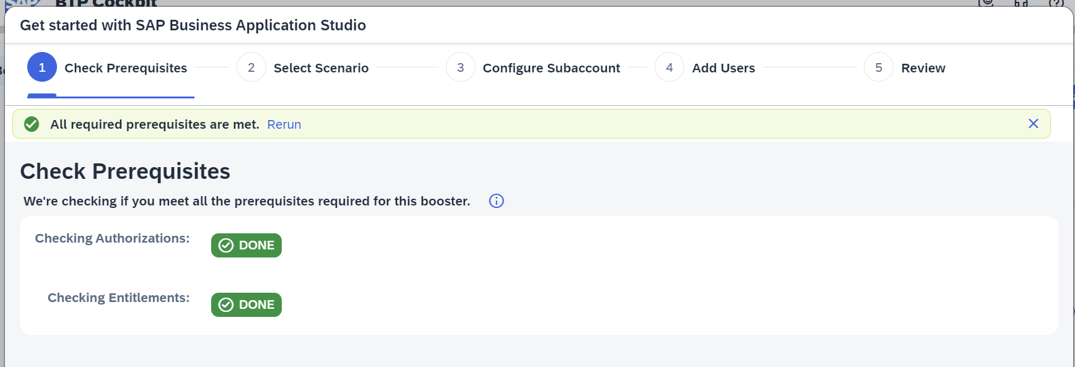

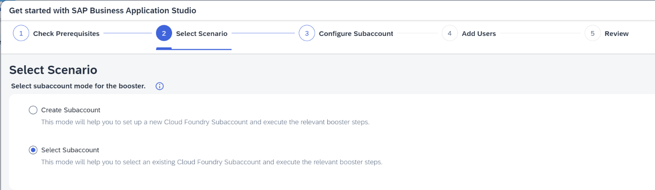

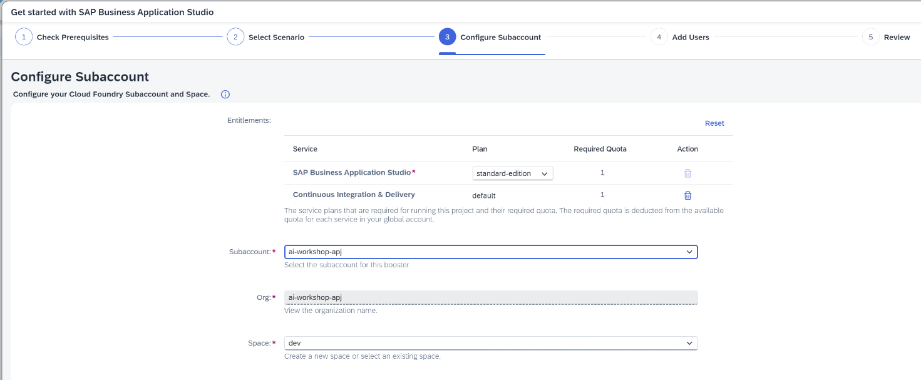

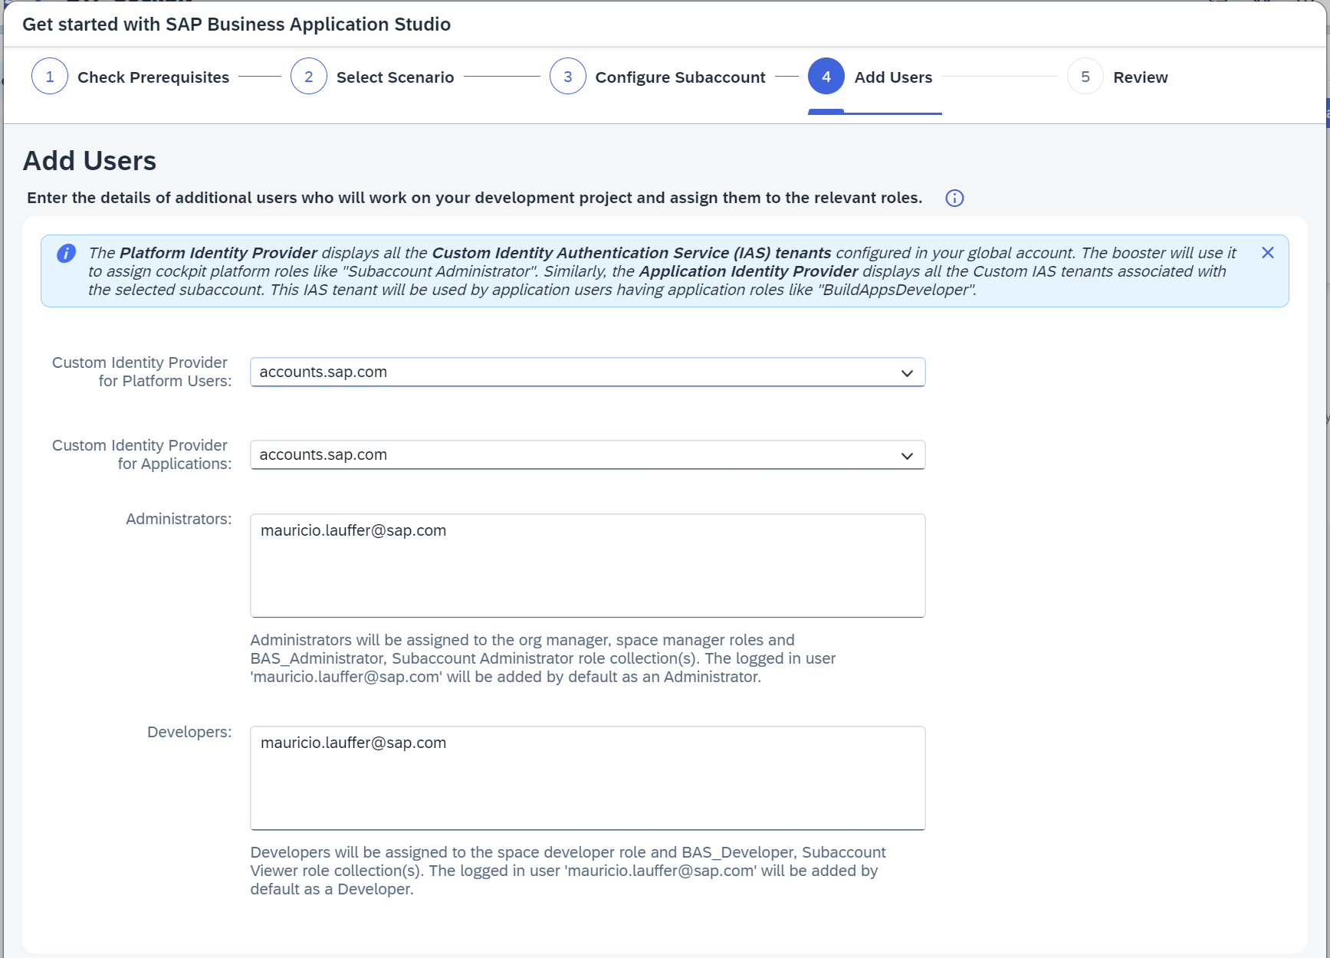

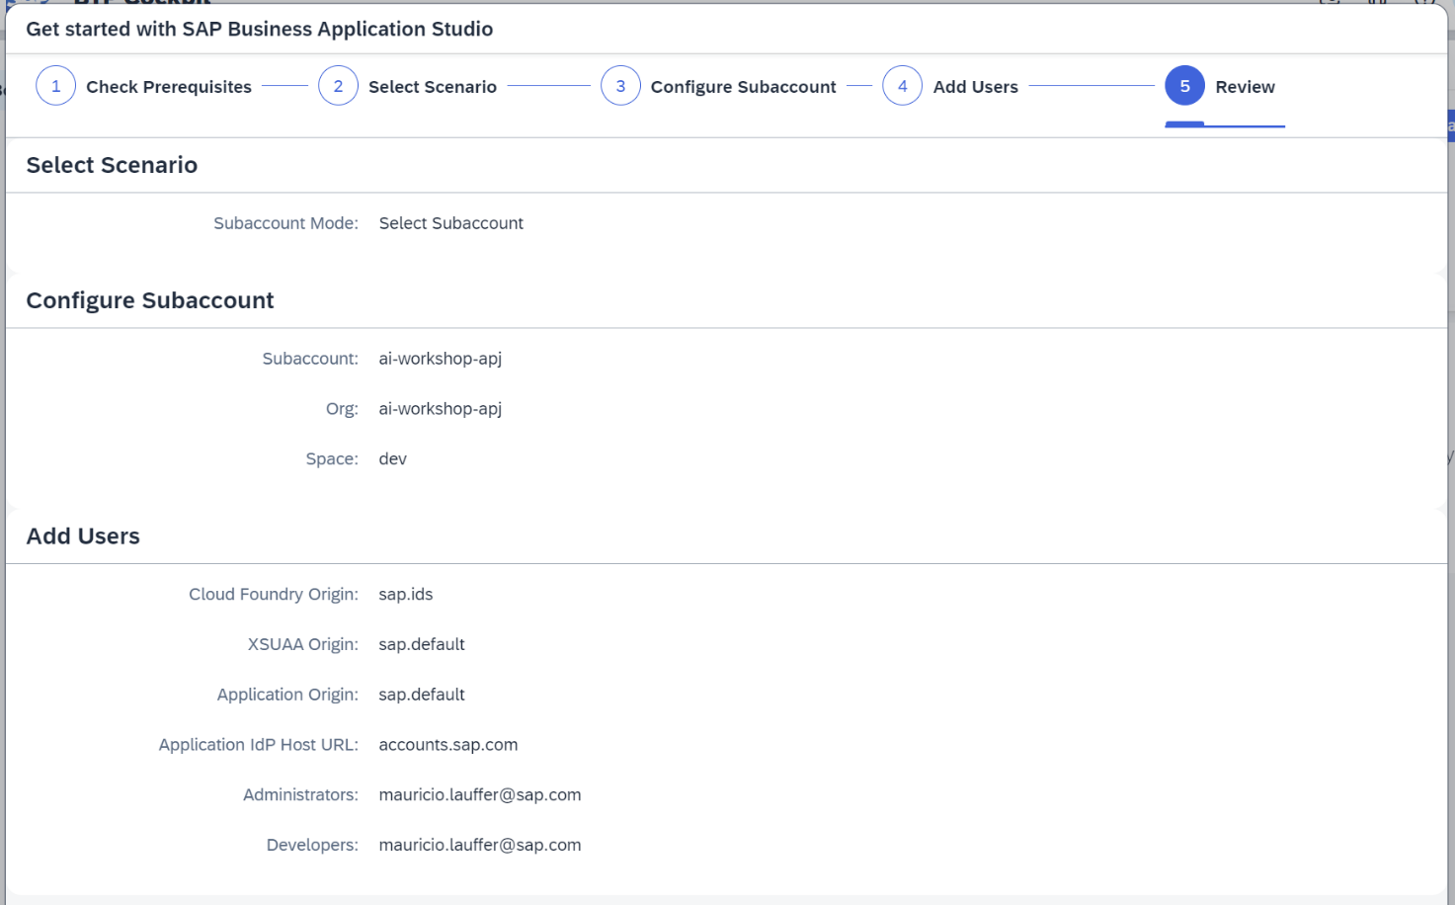

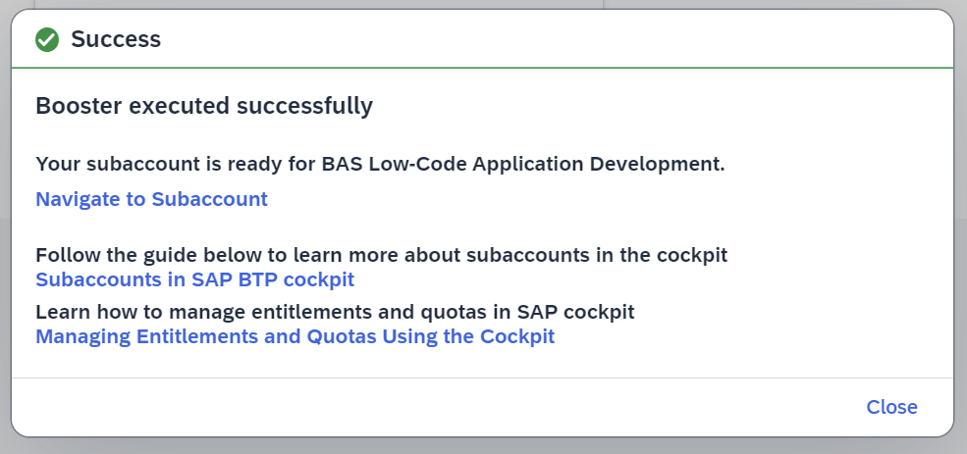

# SAP Build Work Zone, standard edition

**Plan name:** standard (Application)

**Manual setup:** <https://help.sap.com/docs/build-work-zone-standard-edition/sap-build-work-zone-standard-edition/initial-setup>

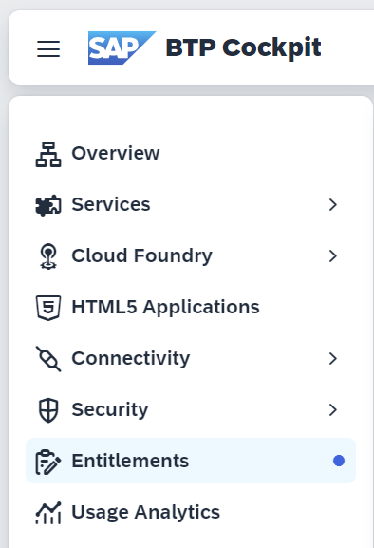

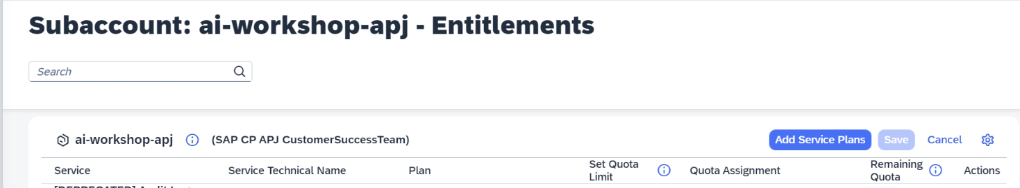

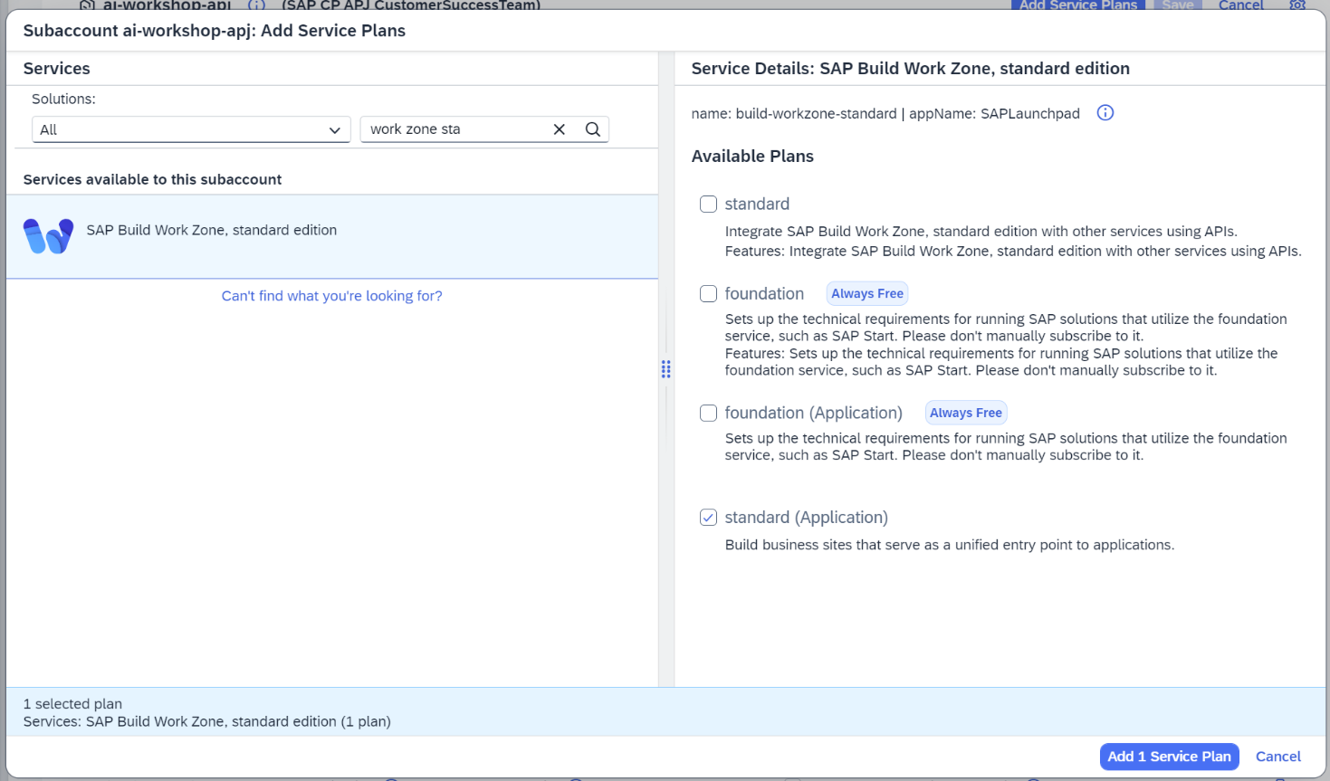

Click on the **Save button**.

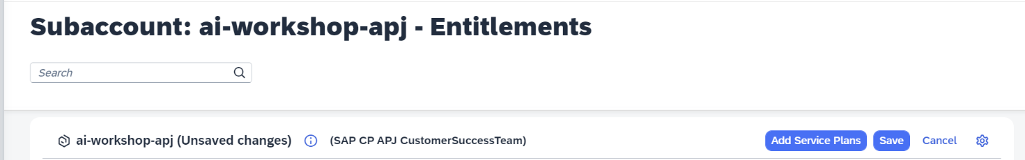

Click on **Service Marketplace**.

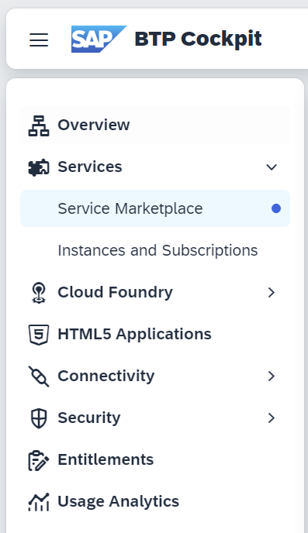

Click on **SAP Build Work Zone, standard edition tile**.

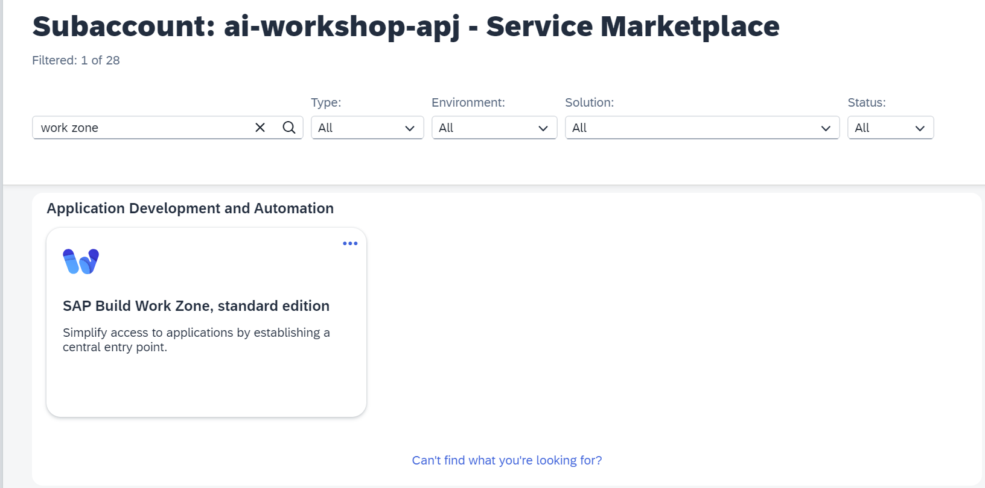

Click on the **Create button**.

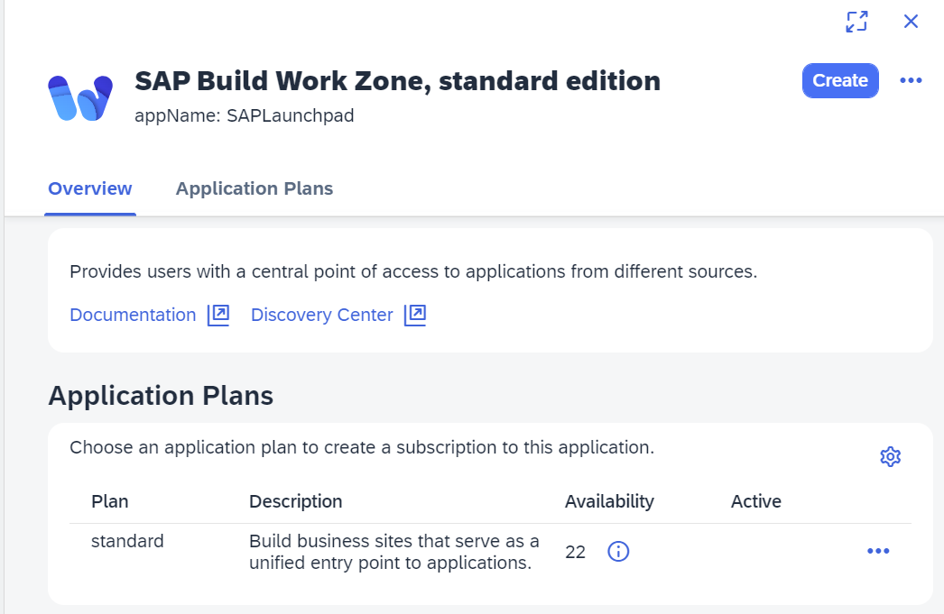

Select the **standard plan**, click on the **Create button**.

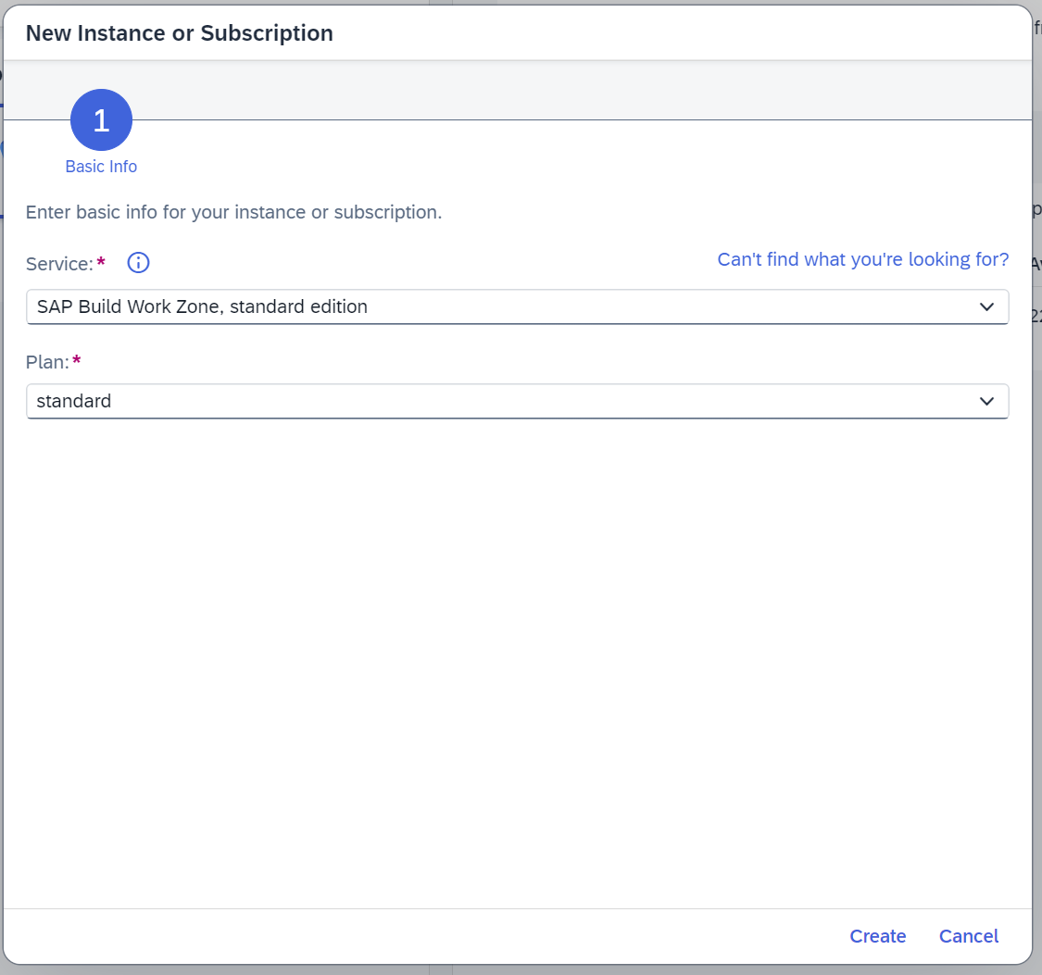

# Configure SAP HANA Cloud Instance

**Plan Name:** hdi-shared

**Plan Name:** schema

**Plan Name:** securestore

**Manual setup:** <https://learning.sap.com/learning-journeys/provision-and-administer-databases-in-sap-hana-cloud/provisioning-a-sap-hana-cloud-sap-hana-database_da0928fe-f283-4633-b81e-633276f99dff>





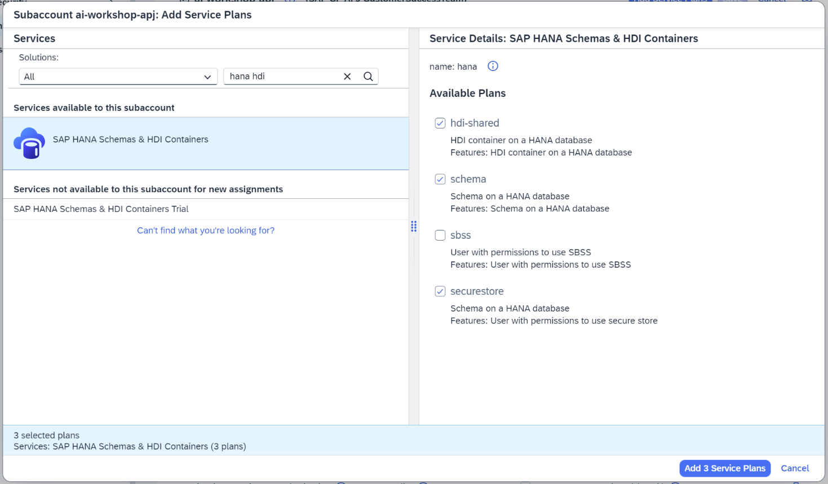

Click on the **Save button**.



Click on **Instances and Subscriptions**.

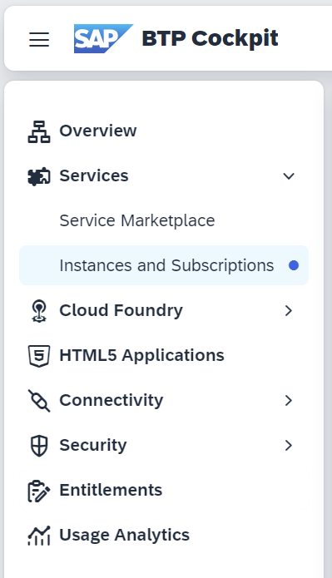

In **the Subscriptions tab**, click on **SAP HANA Cloud**.

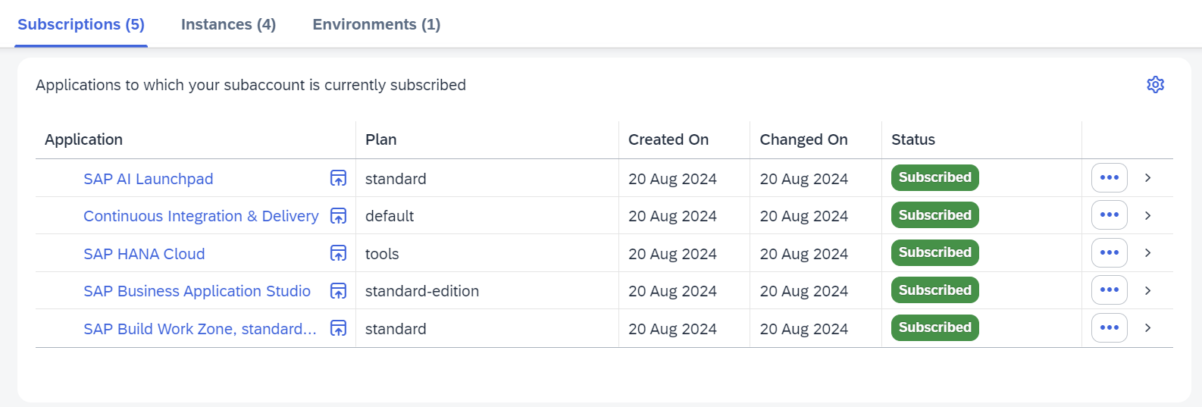

**SAP HANA Cloud Central** will open in a new tab. Click on the **Create Instance button**.

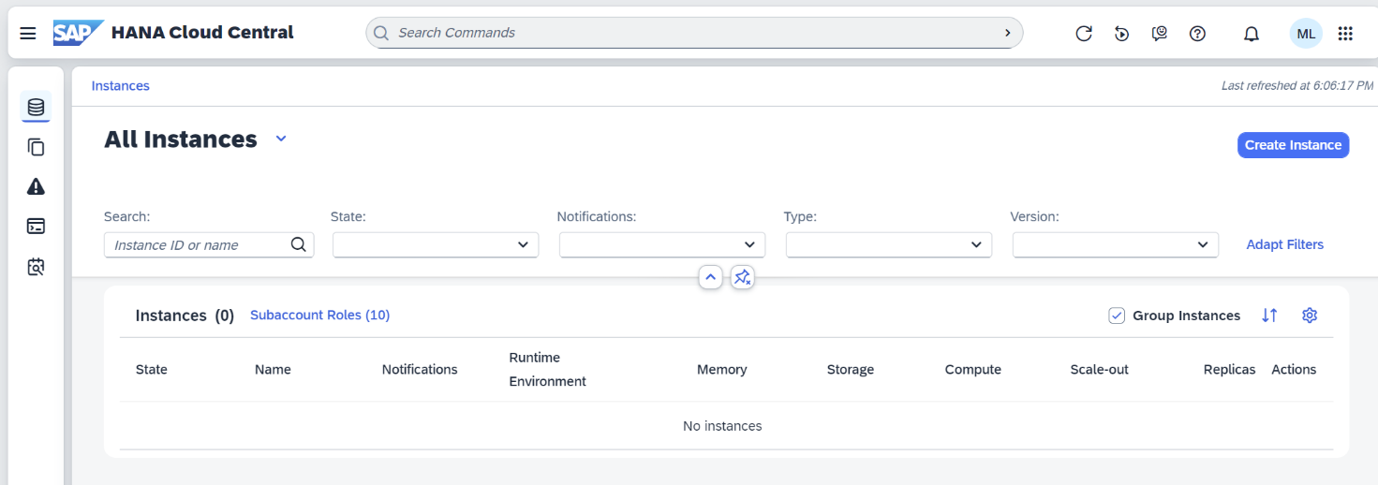

Select **SAP HANA Cloud, SAP HANA Database**. Select the **Cloud Foundry Space** at the bottom of the page, in the **Runtime Environment** section.

If you cannot select it, you need to click on the link to **Sign Into the** **Cloud Foundry Environment**.

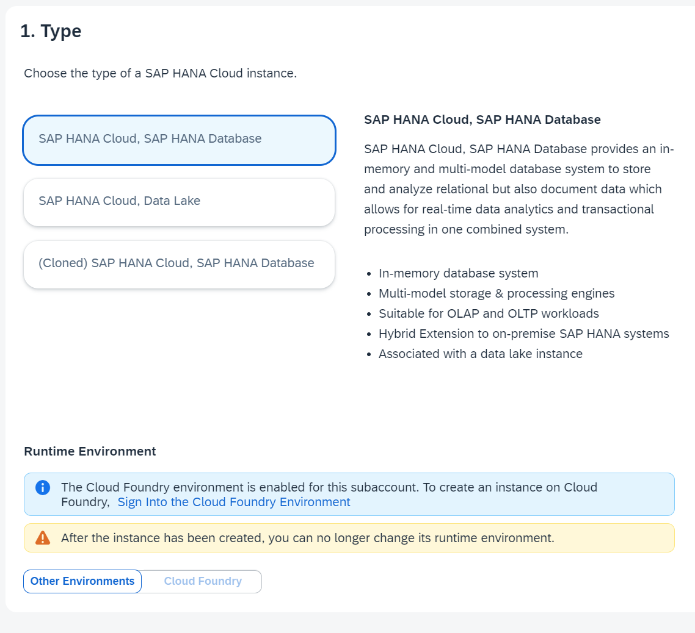

Click on **AUTHORIZE** button.

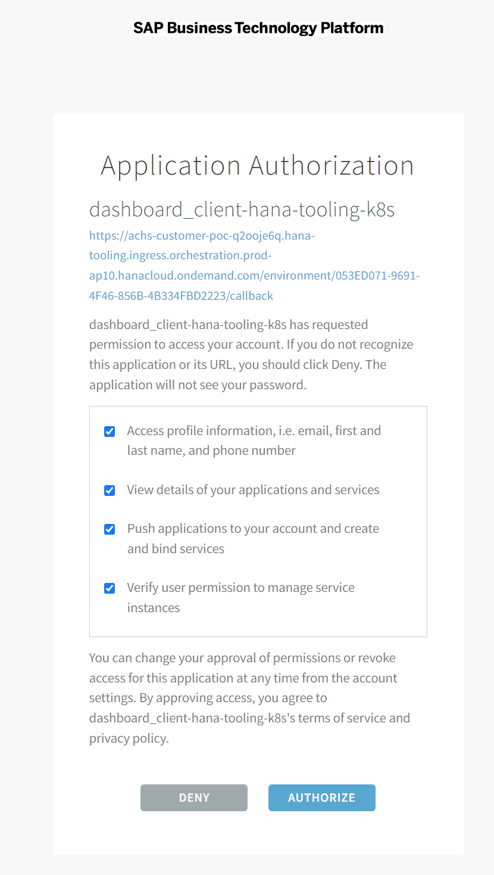

Click on **Close** button.

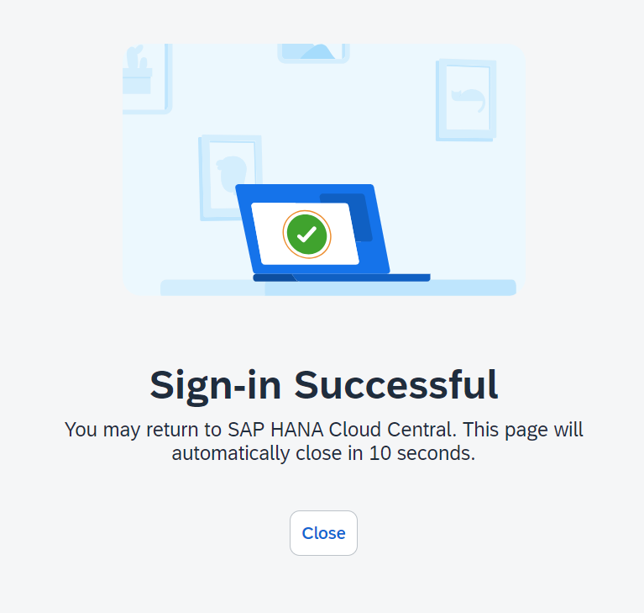

Back to the **SAP HANA Cloud** configuration, select **Cloud Foundry** as the **Runtime Environment,** andselect the **Space**.

Click on the **Next Step button**.

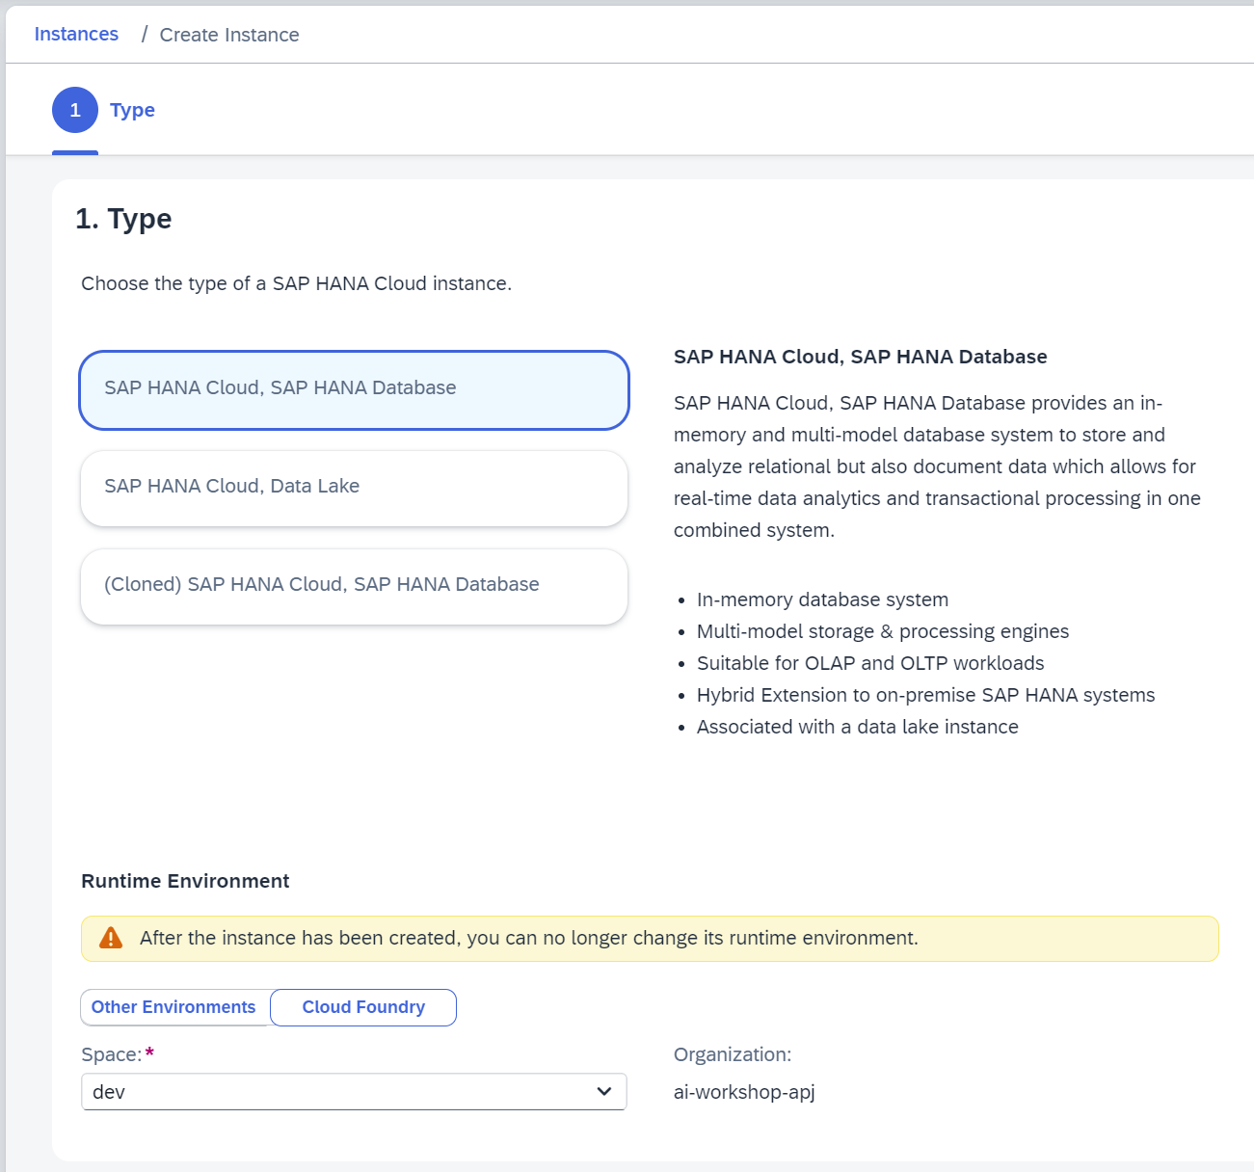

Enter an **Instance Name**, enter the **Administrator Password**, click on **Next Step button**.

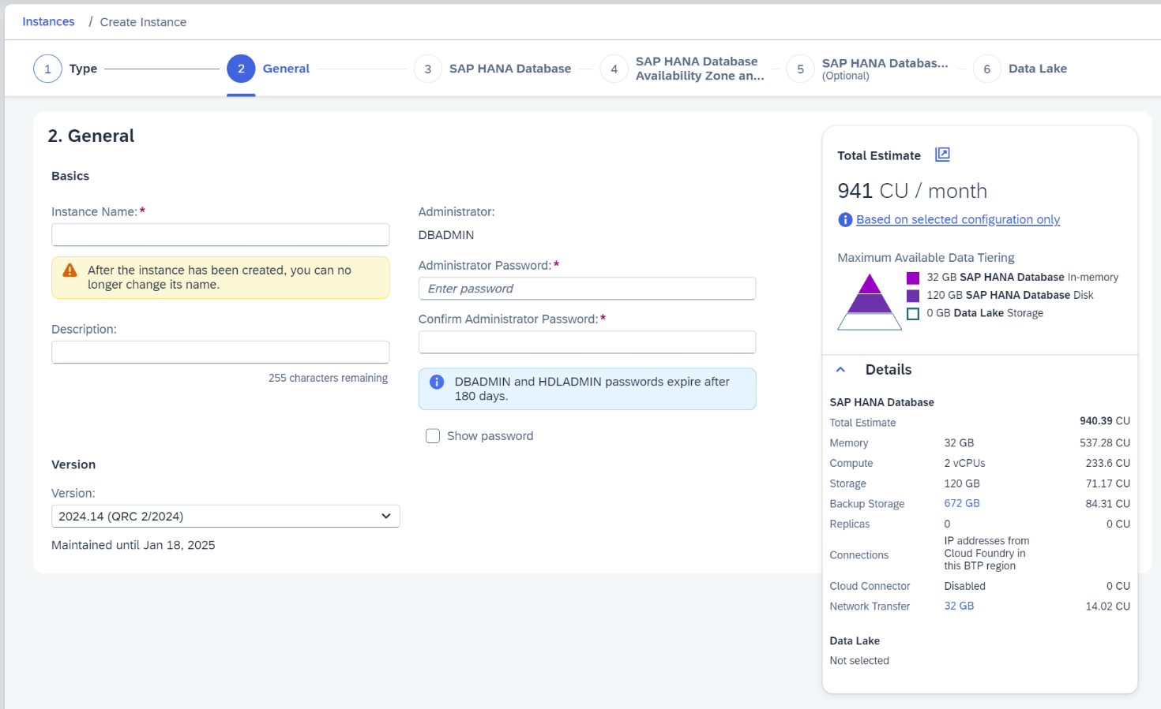

Change **Memory** and **Storage** if required. Click on the **Next Step button**.

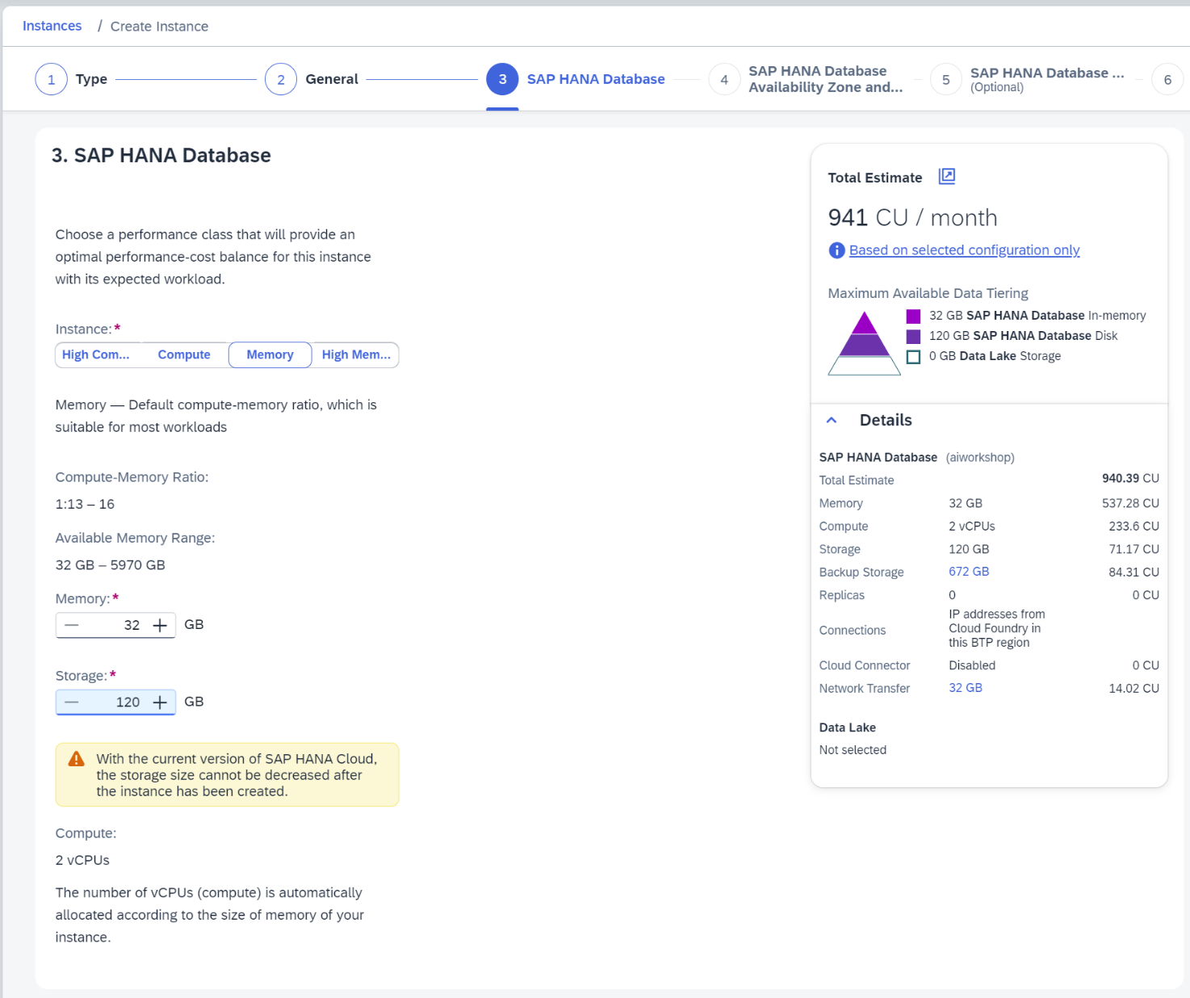

Change **Availability Zone** if required. Click on the **Next Step button**.

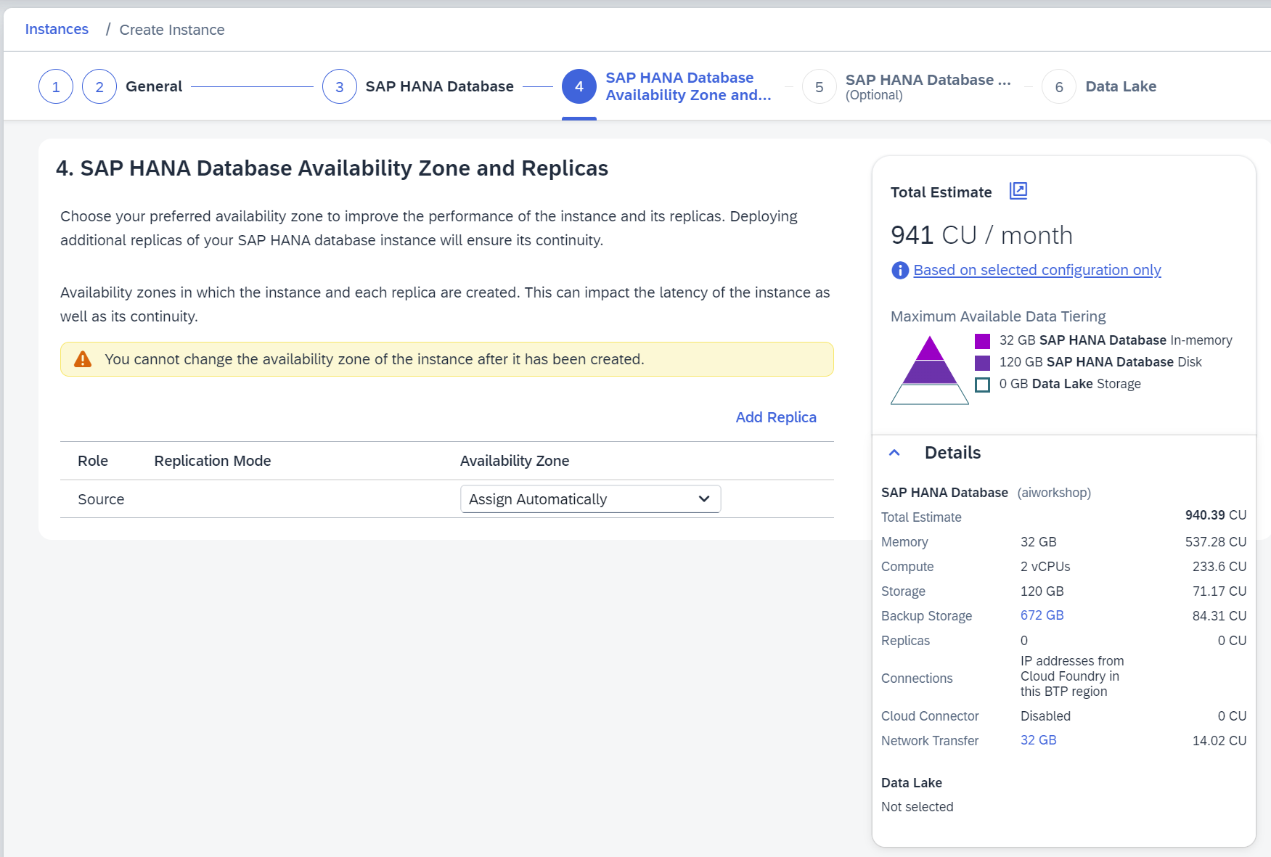

Select **Allow all IP addresses** (this is for workshop only; you may not want to do it for production instances). Click on the **Next Step button**.

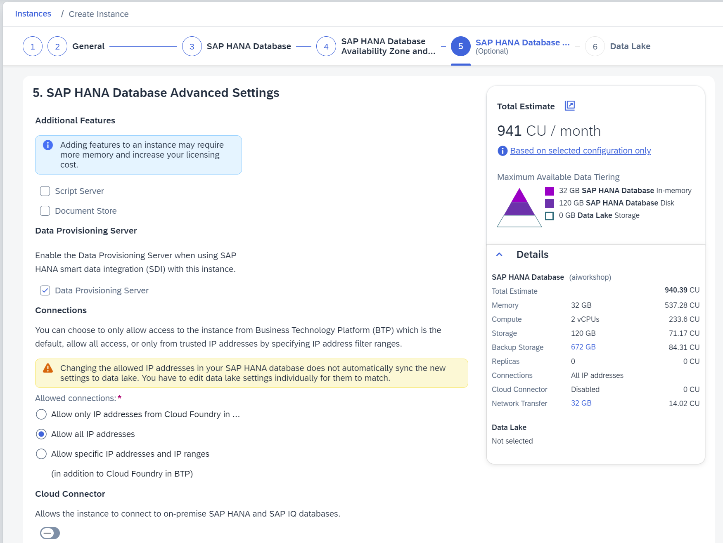

Click on the **Review and Create button**.

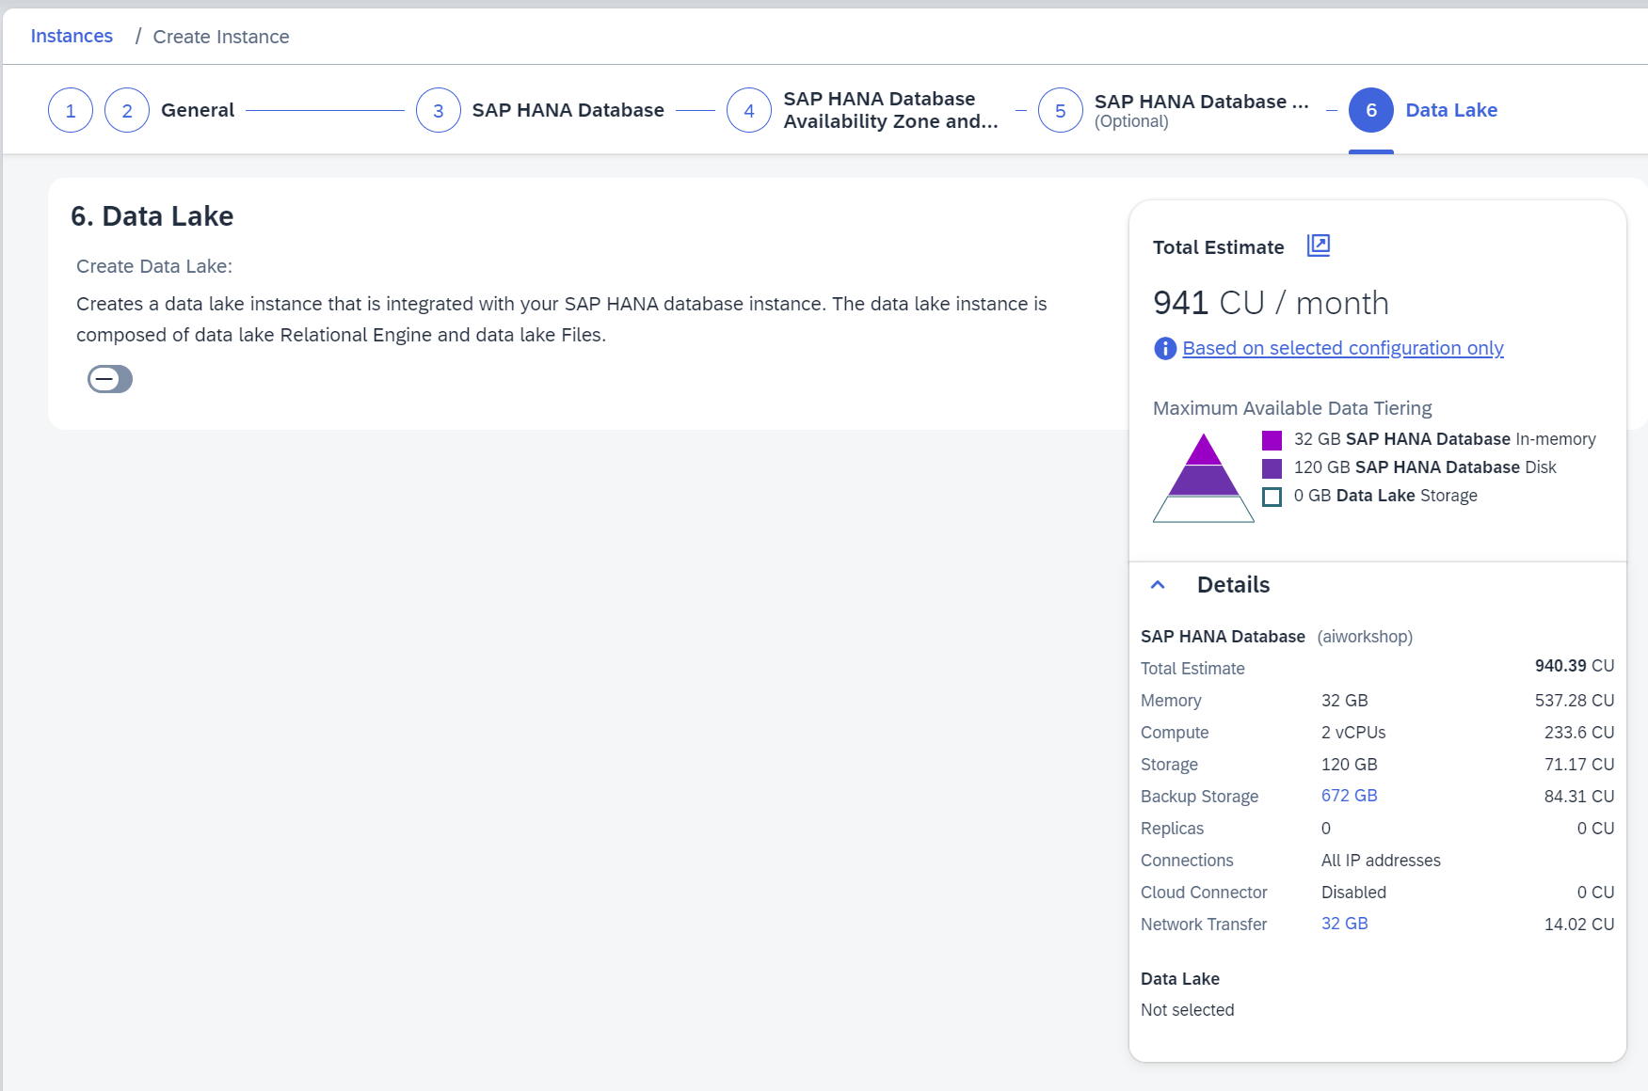

Click on the **Create Instance button**.

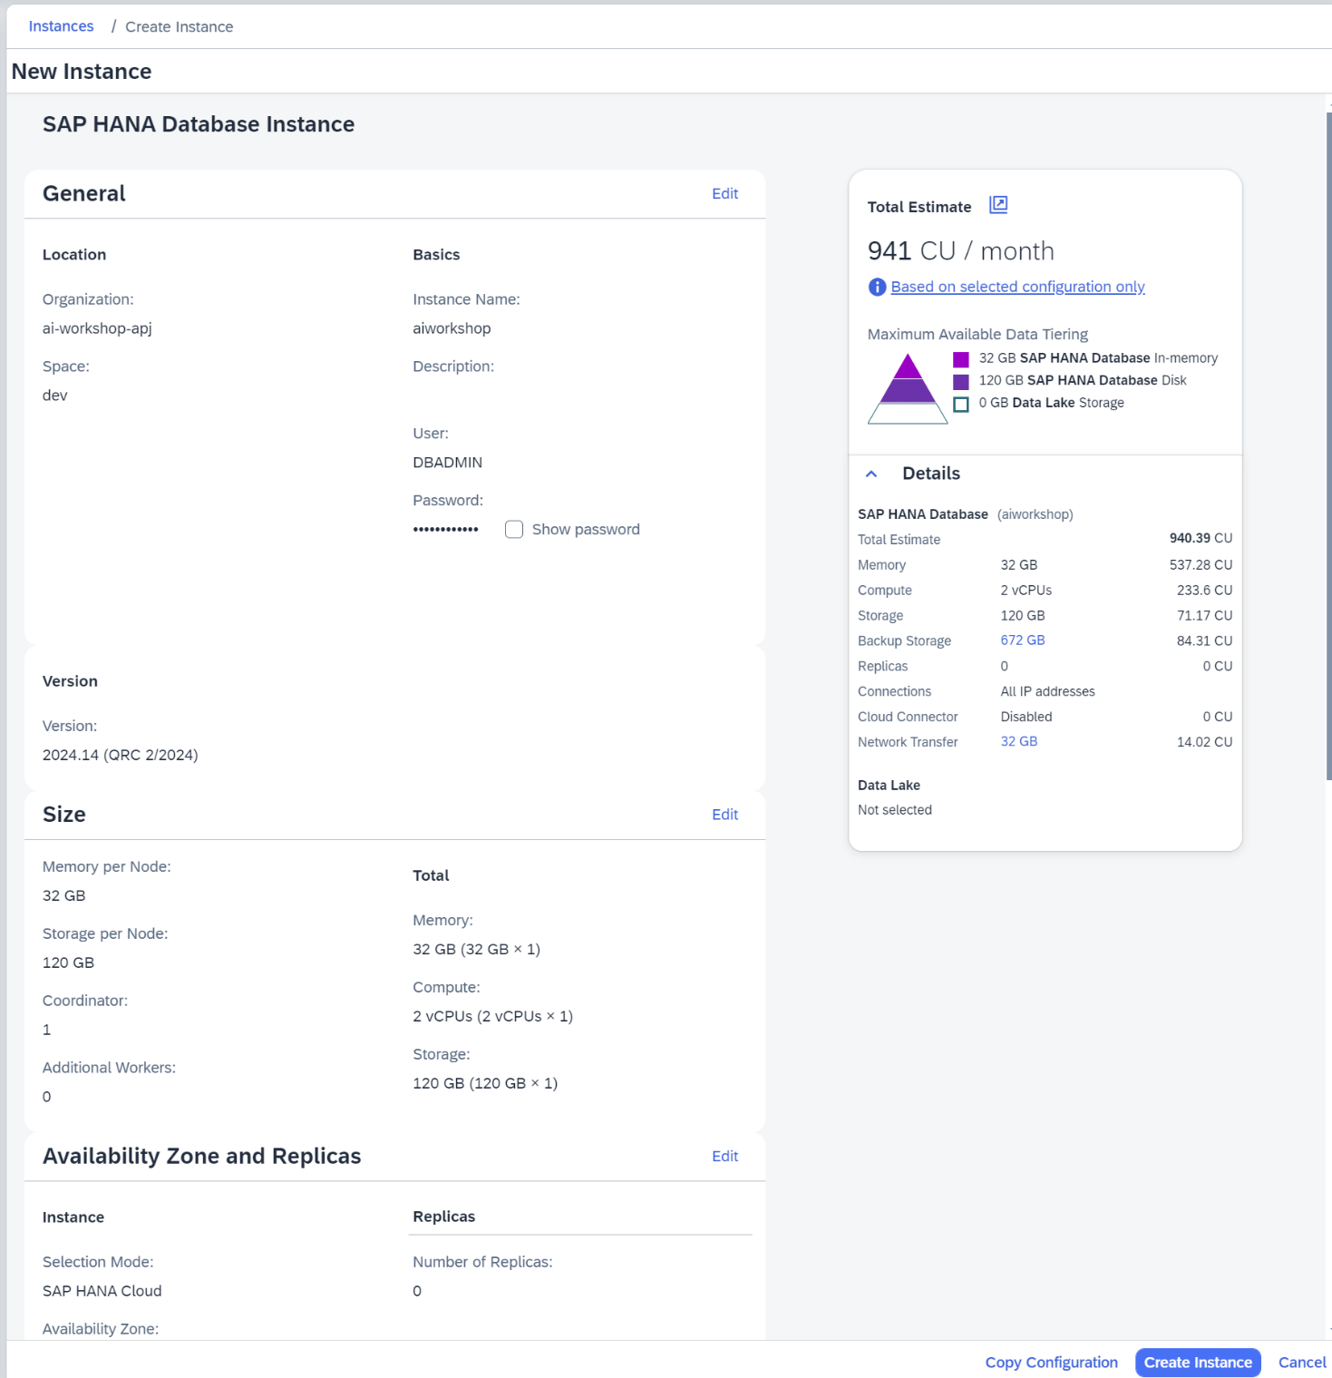

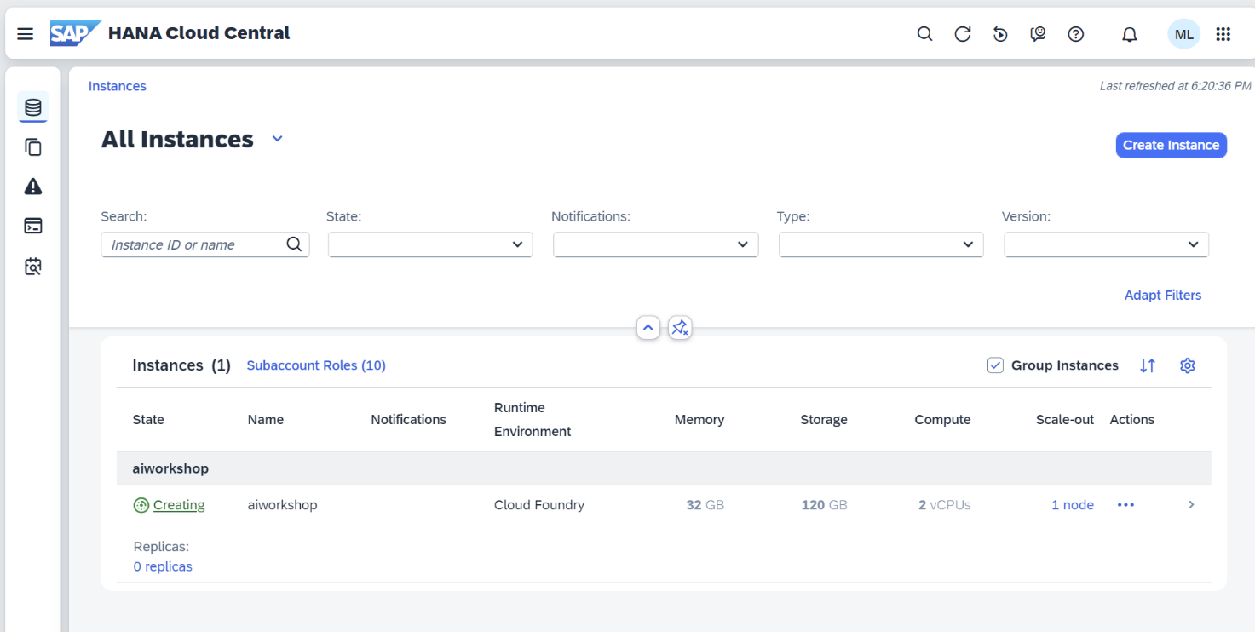

# Configure AI Launchpad Integration to AI Core

In the SAP BTP Cockpit, go to the subaccount, navigate to **Instances and Subscriptions**.

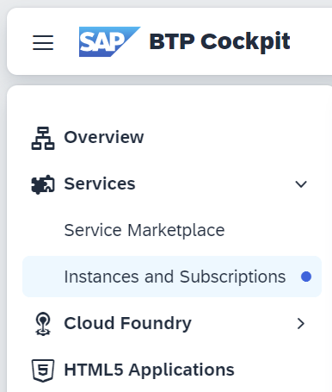

On **the Instances tab**, click on the AI Core service instance (**default_aicore** in the image).

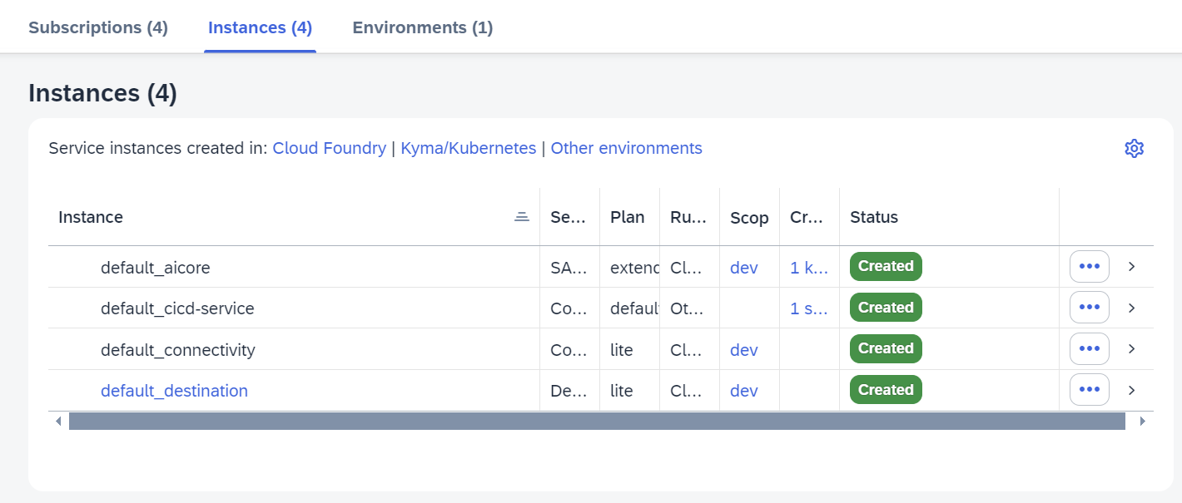

Click on the **Thee Dots button**, then click on **Download** to get the **Service Key**.

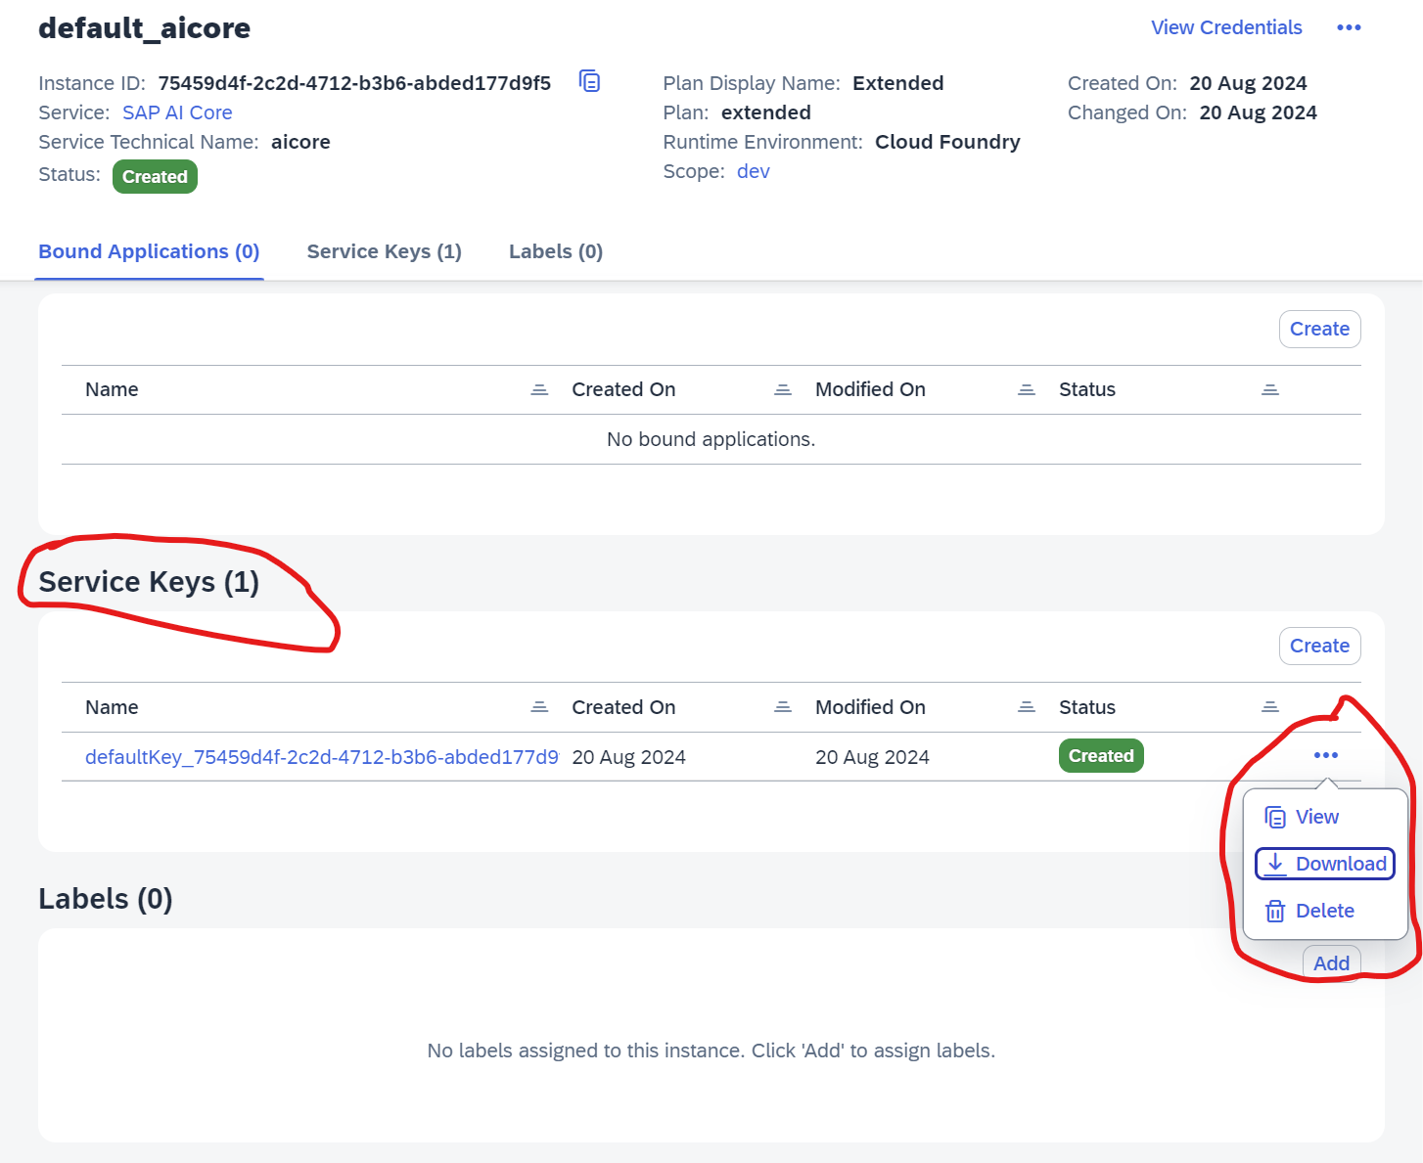

Go back to **Instances and Subscriptions**. In the **Subscriptions tab**, click on **SAP AI Launchpad**.

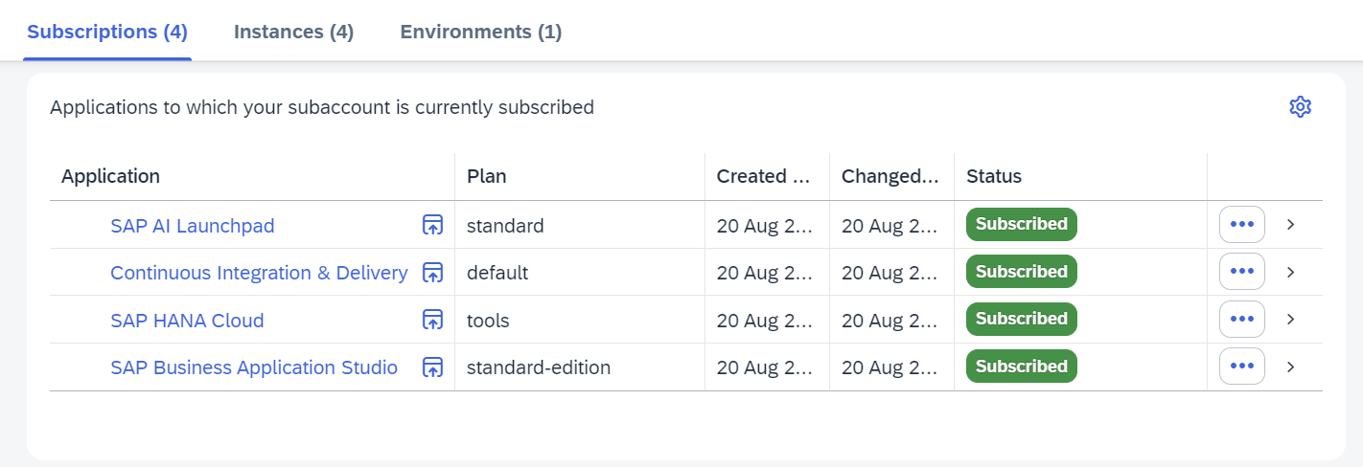

**SAP AI Launchpad** will open in a new tab, navigate to it. Click on the **Add button**.

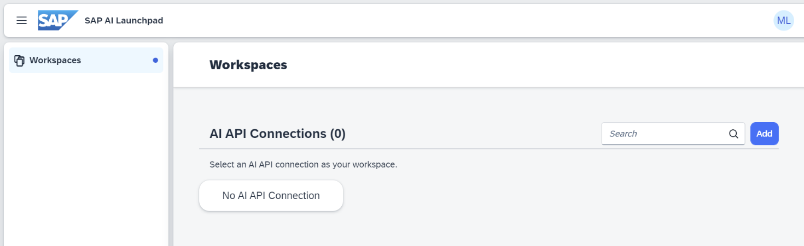

The popup is used to create a new connection. Set a **Connection Name**, click on the **Service Key button**, select the **Service Key** previously downloaded from the **SAP** **AI Core service** (all fields will be filled up), click on **Create button**.

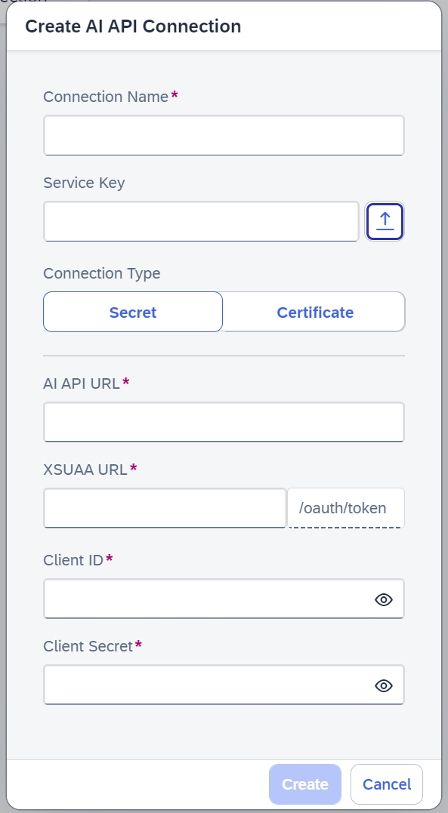

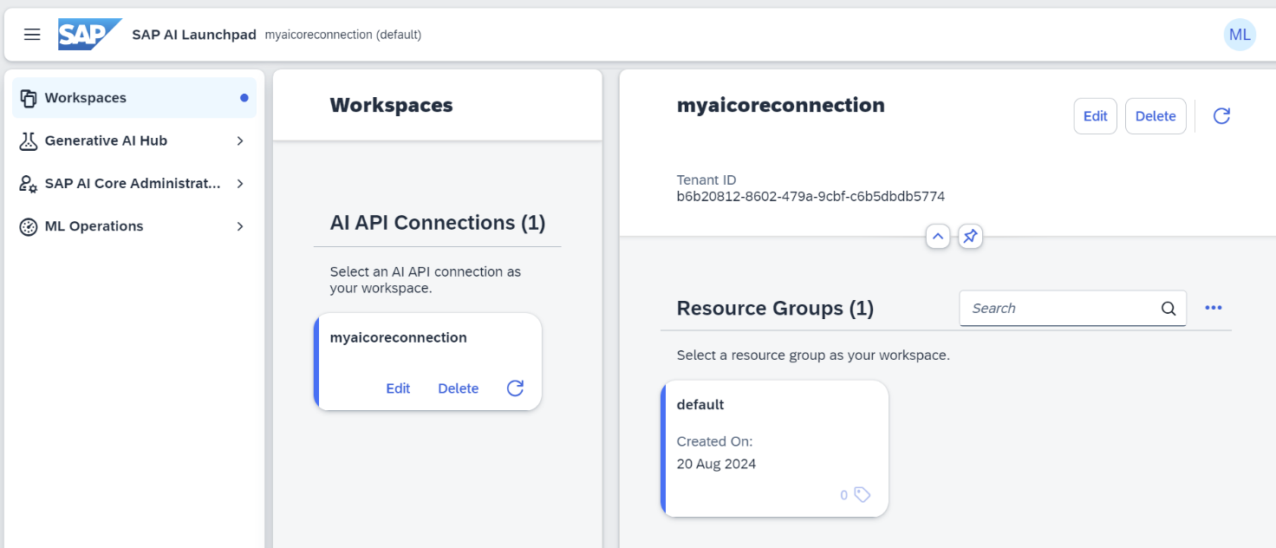

# Create AI Core Destination

**SAP BTP Destinations**: <https://help.sap.com/docs/connectivity/sap-btp-connectivity-cf/managing-destinations>

In the SAP BTP Cockpit, navigate to **Destinations**.

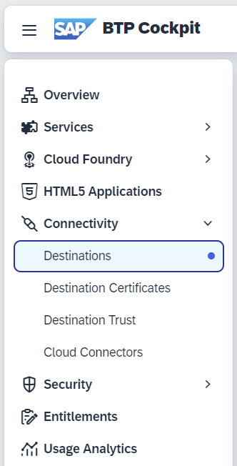

Click on **Create Destination**.

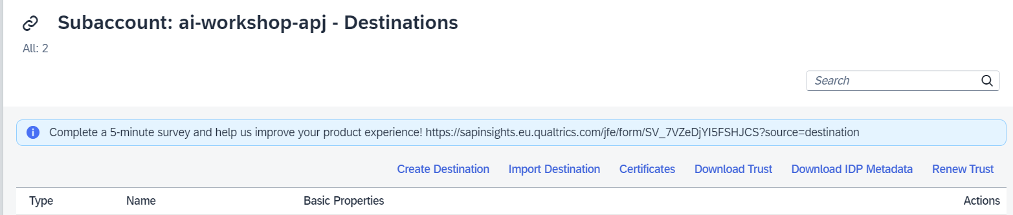

Create a new destination with the properties below. The placeholders (<serviceurls.AI_API_URL>, <clientid>, <clientsecret>, <url> ) must be replaced with the values from the **AI Core credentials** below mentioned:

**Name**=GENERATIVE_AI_HUB

**Type**=HTTP

**URL**=<serviceurls.AI_API_URL>/V2

**ProxyType**=Internet

**Authentication**=OAuth2ClientCredentials

**clientId**=<clientid>

**clientSecret**=<cliensecret>

**tokenServiceURL**=<url>/oauth/token

**tokenServiceURLType**=Dedicated

**HTML5.Timeout**=300000

**HTML5.DynamicDestination**=true

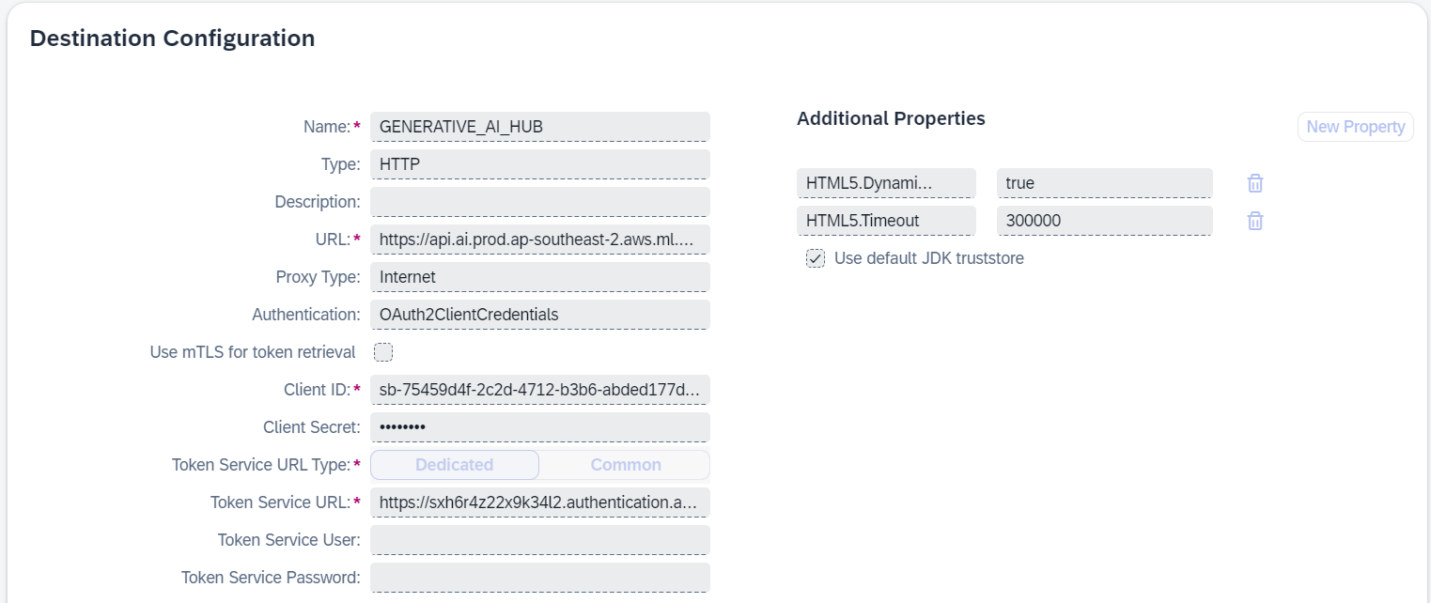

### The information required to create the destination will be found in the AI Core’s Service Key instance.

In the **SAP BTP Cockpit**, navigate to **Services** > **Instances and Subscriptions**.



On the **Instances tab**, click on the AI Core service instance (**default_aicore** in the image).



Click on **View Credentials** at the top, or, on the **Service Key Name** to open a dialog with the information required in the **Destination**.

